**CSP2020-senior 试卷**

估分网站：https://[www.oitiku.com/](http://www.oitiku.com/)

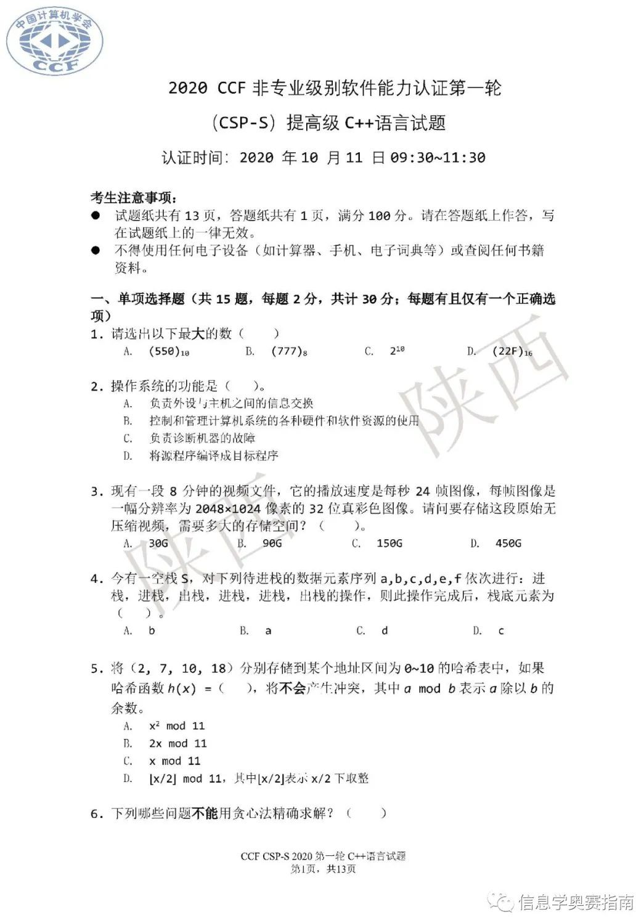

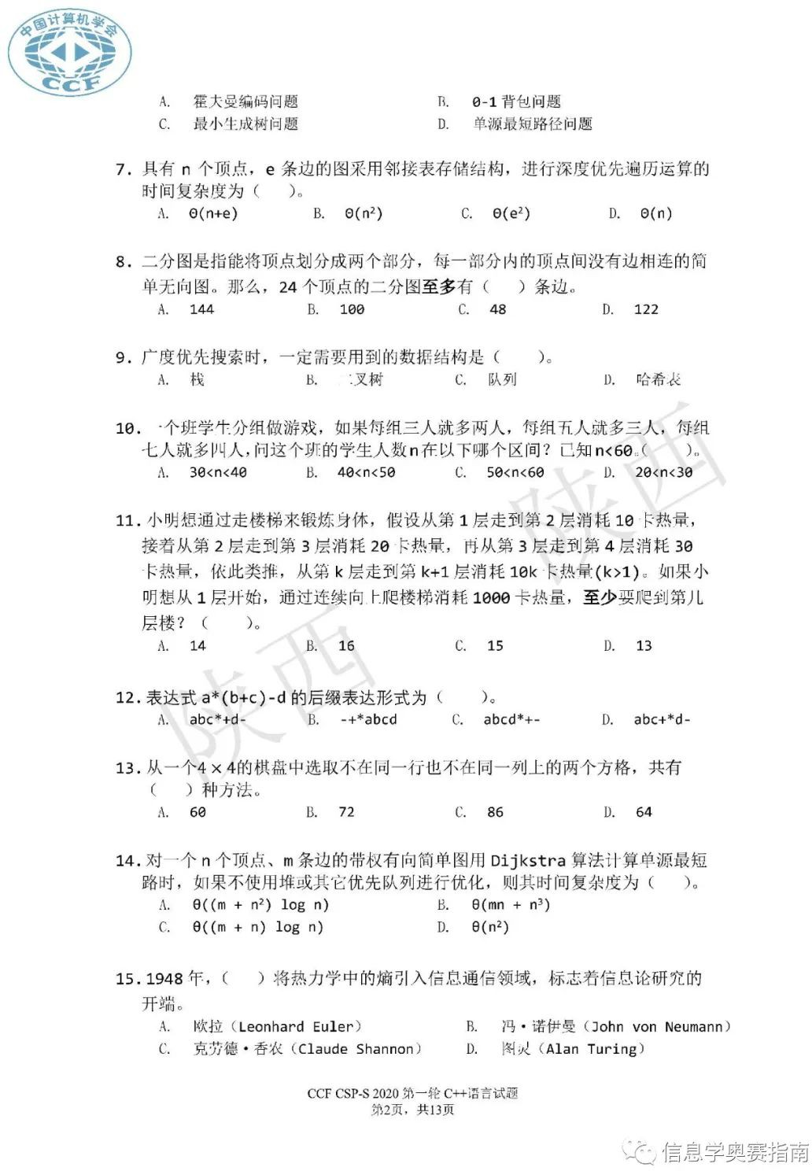

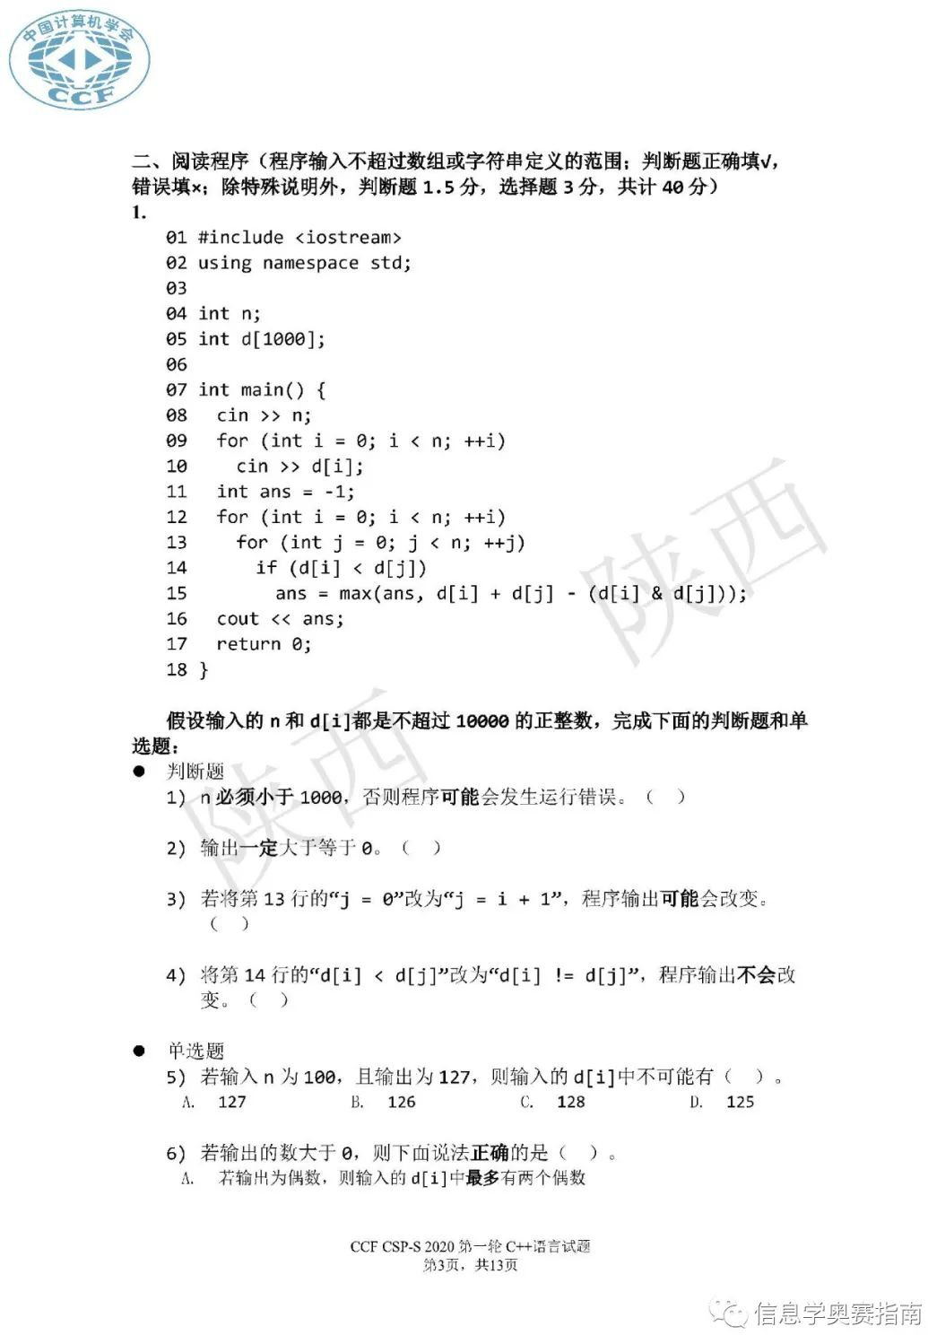

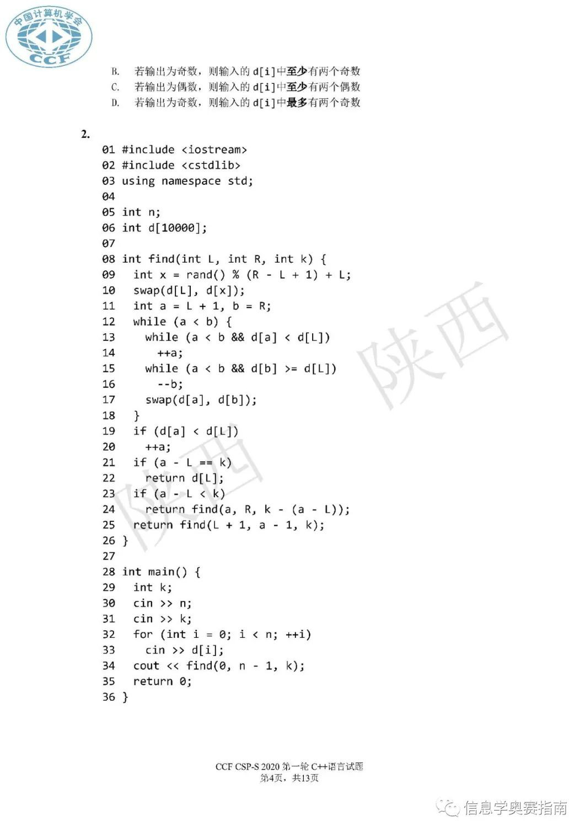

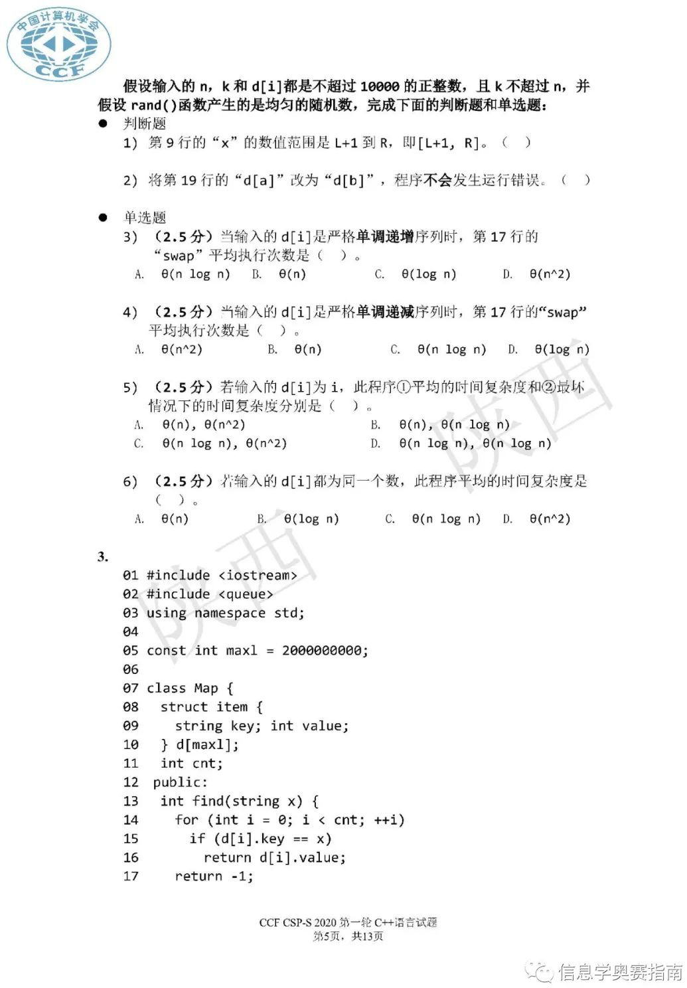

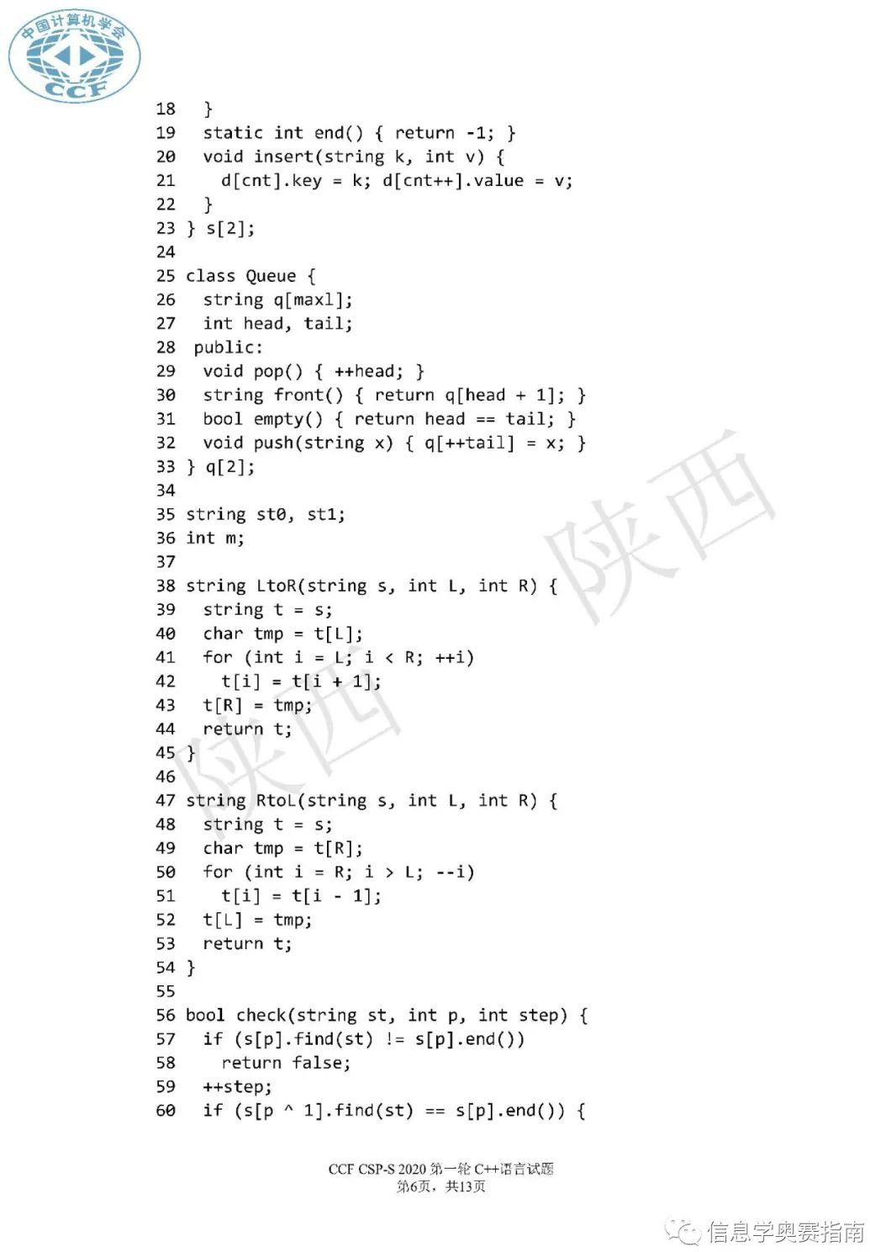

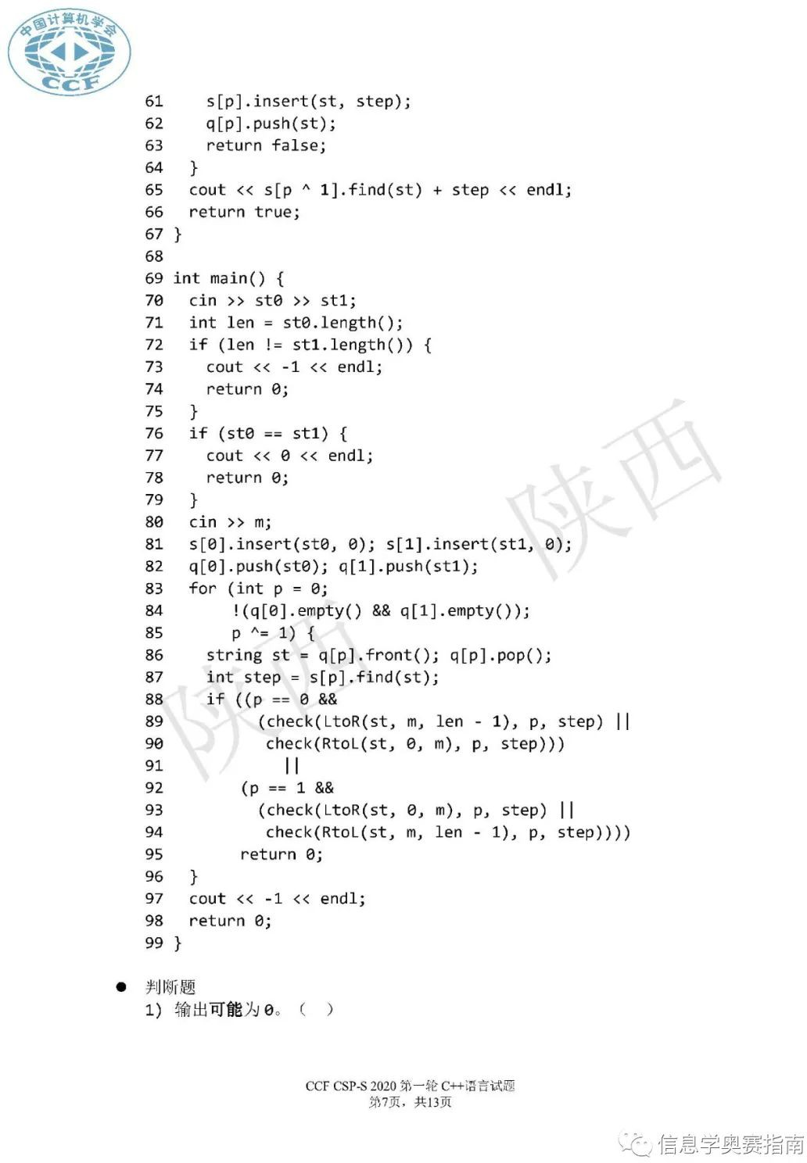

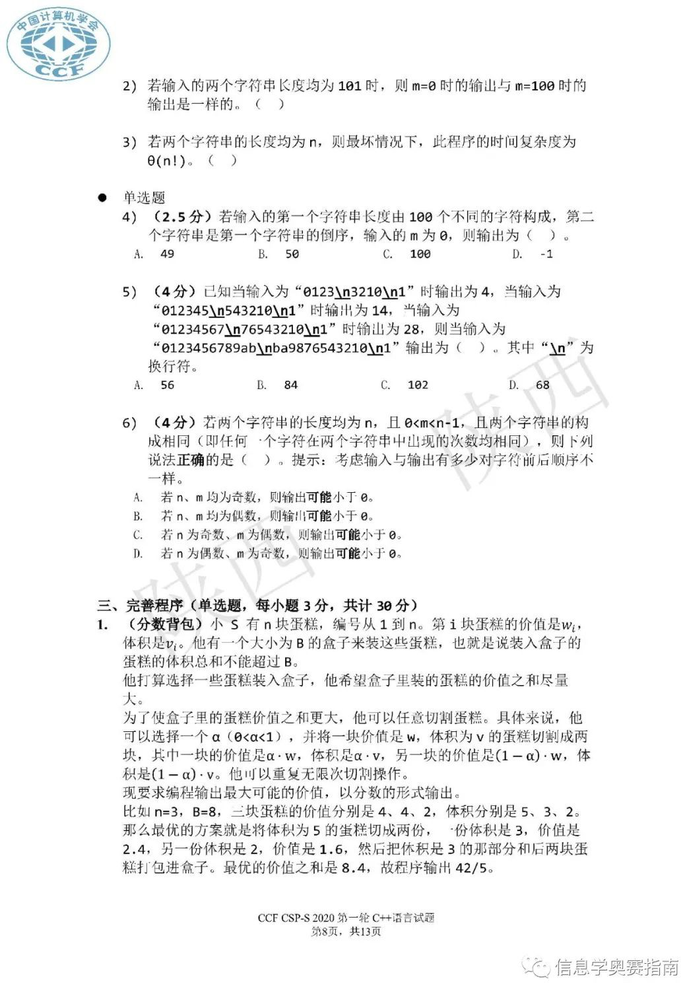

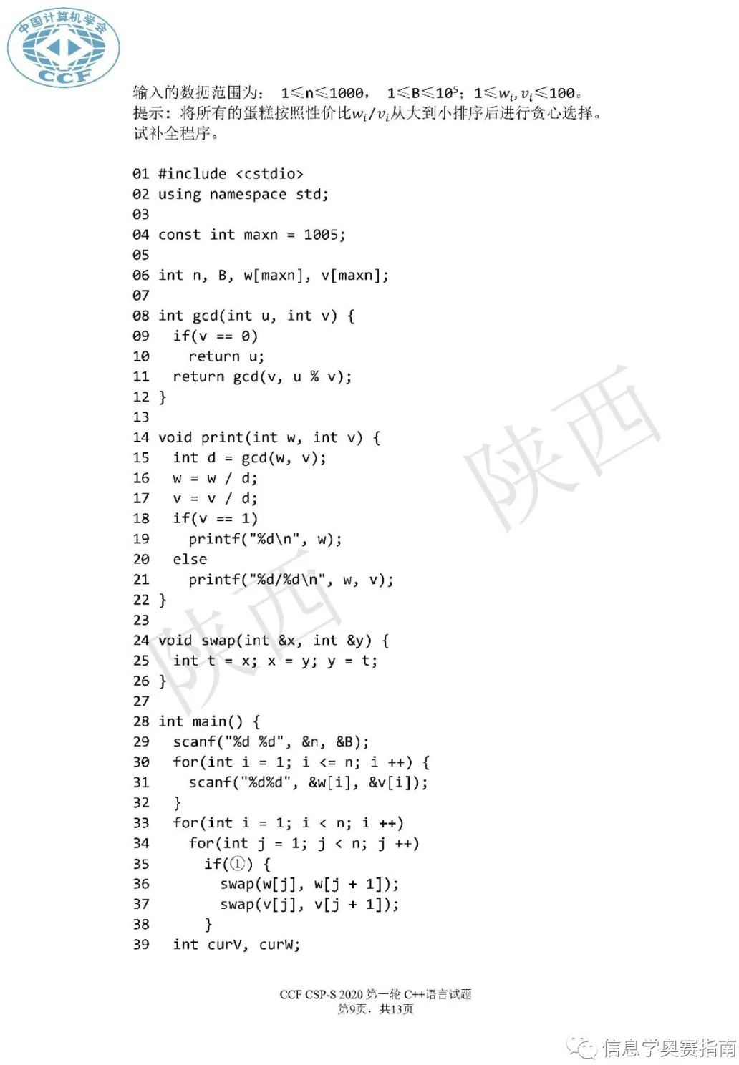

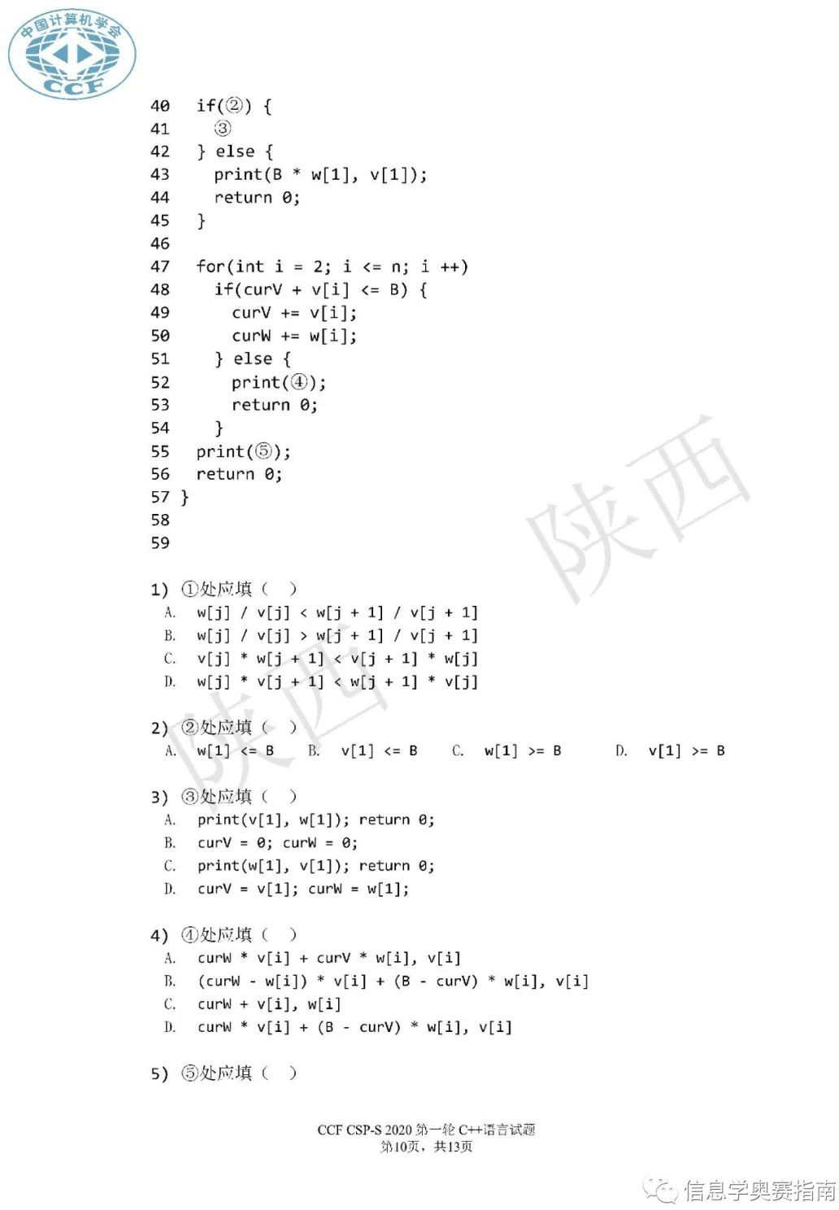

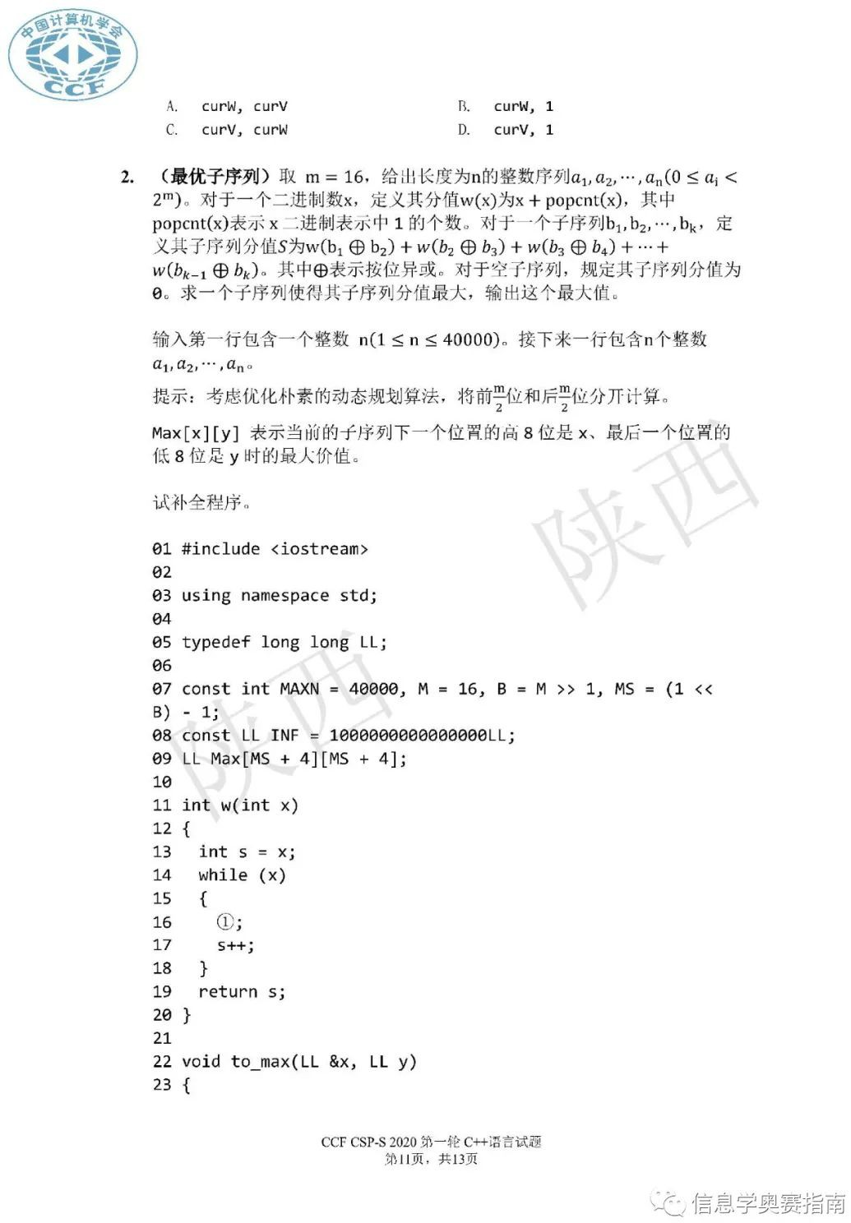

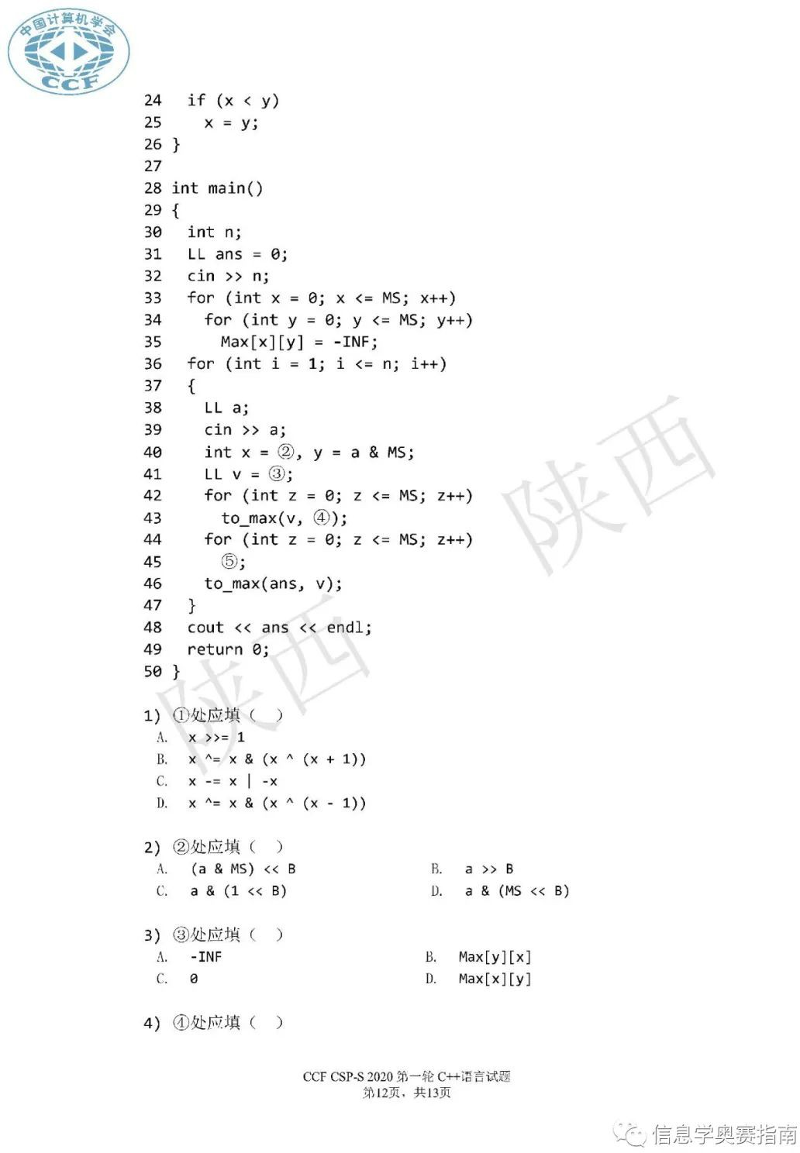

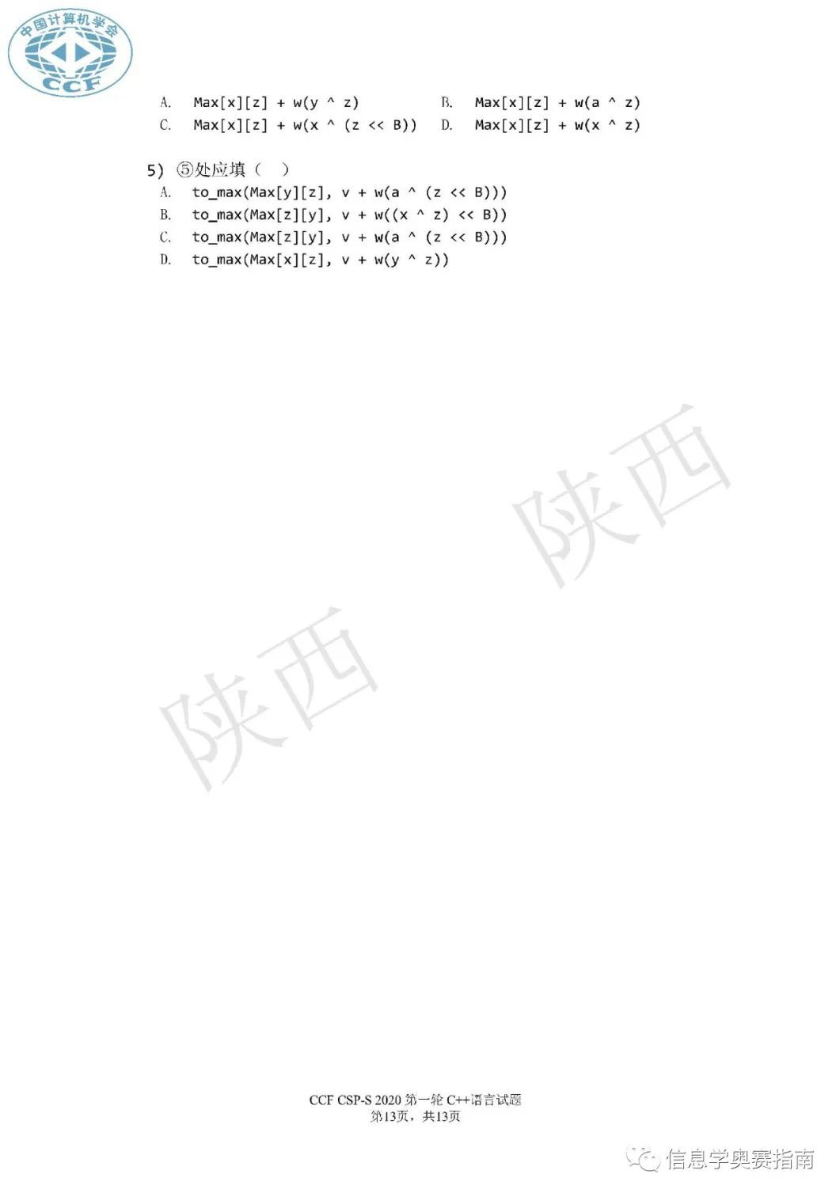

**CSP2020-junior 试卷**

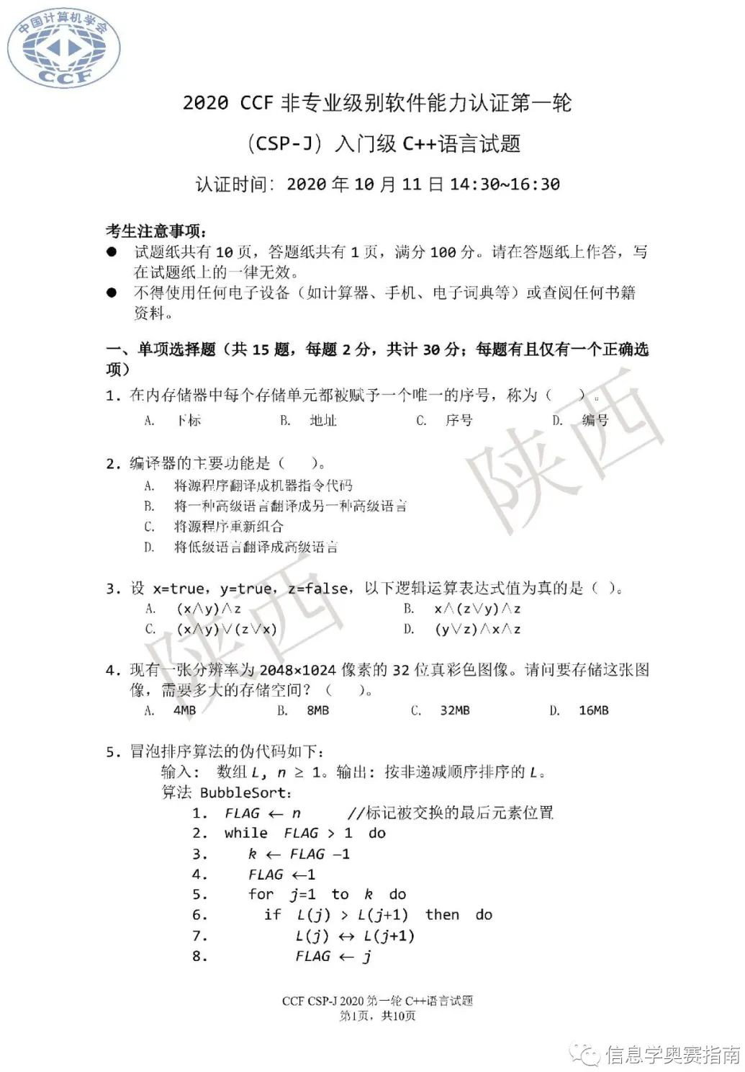

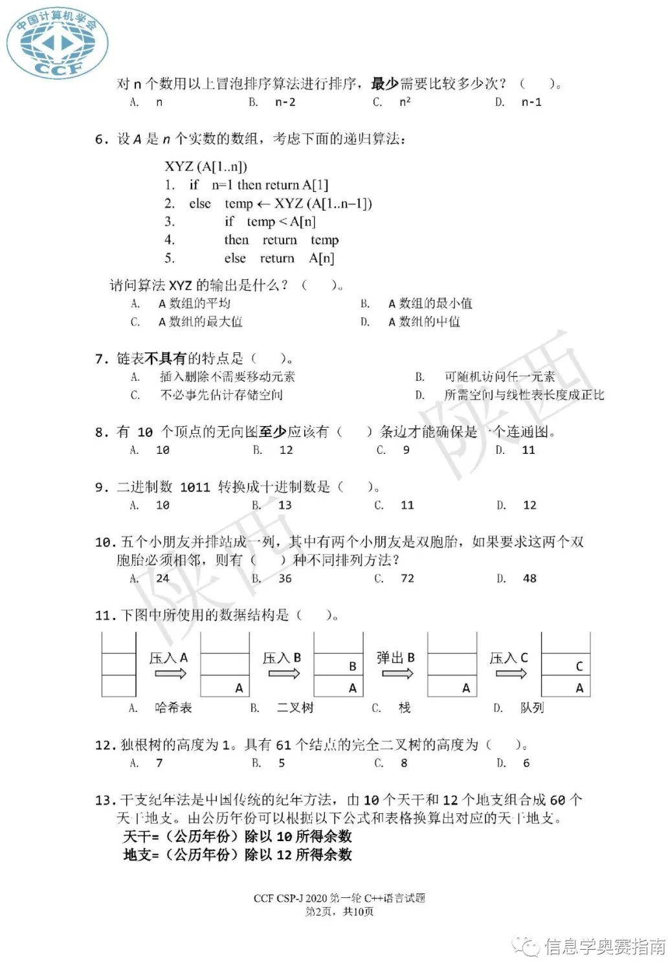

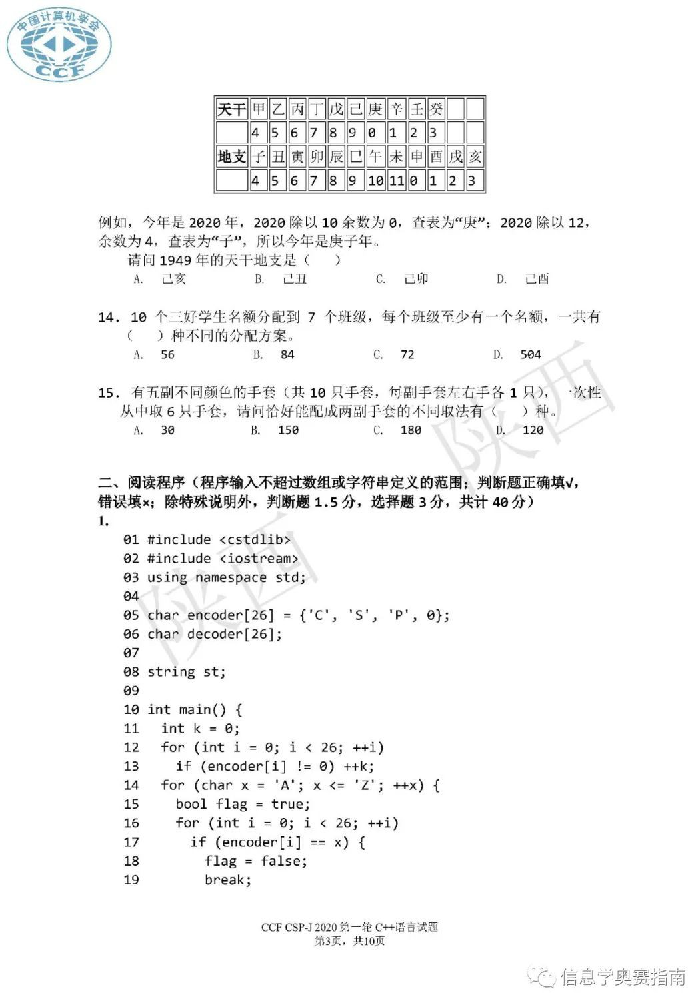

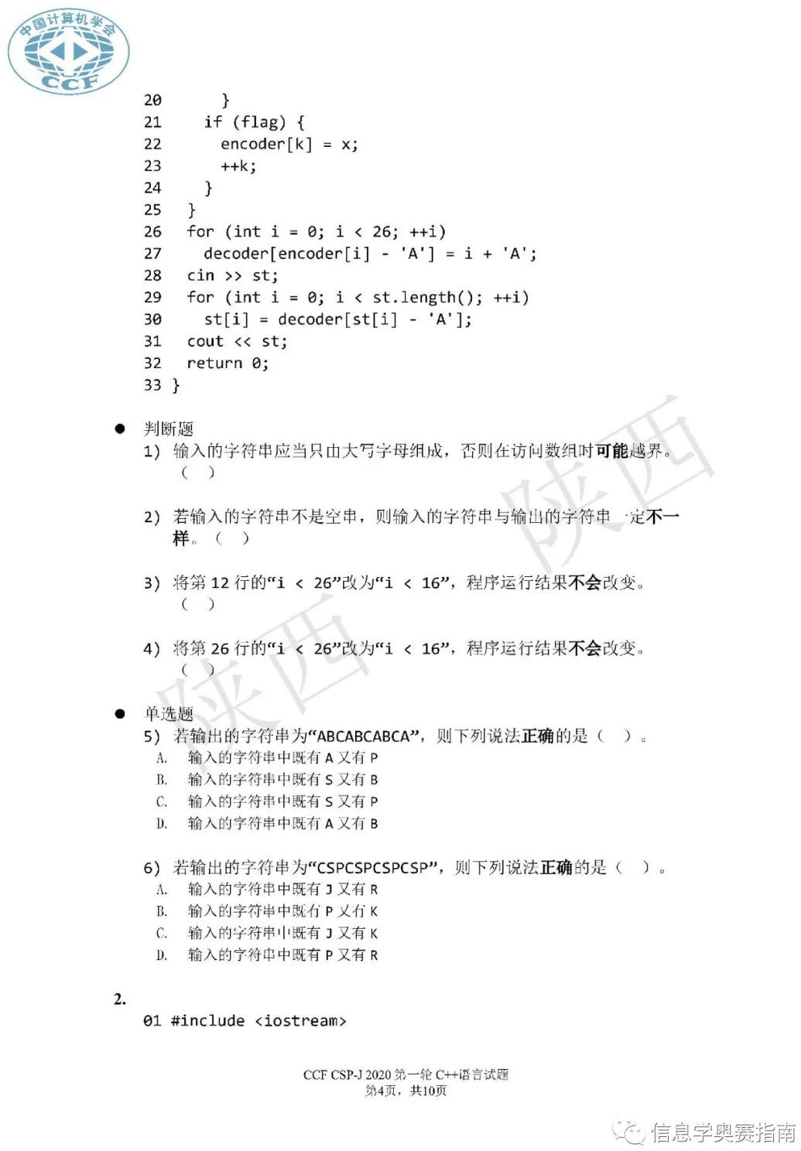

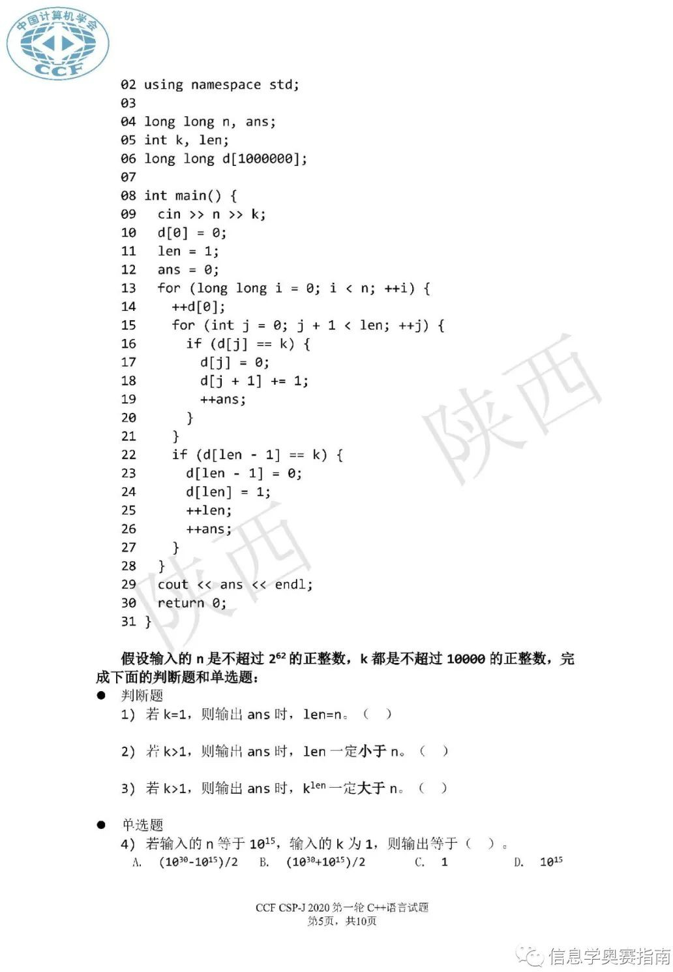

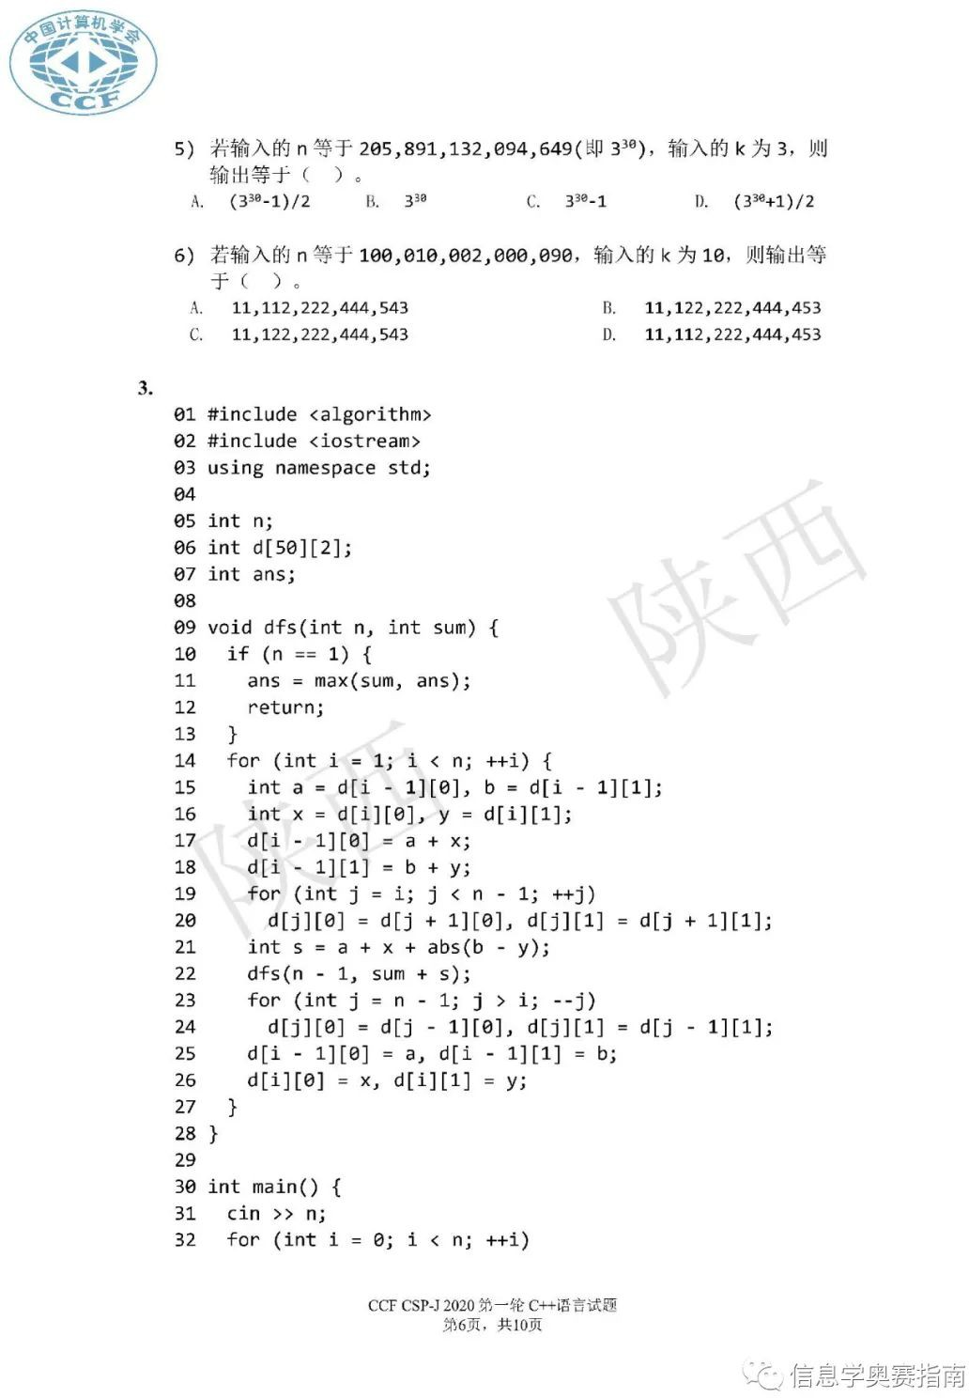

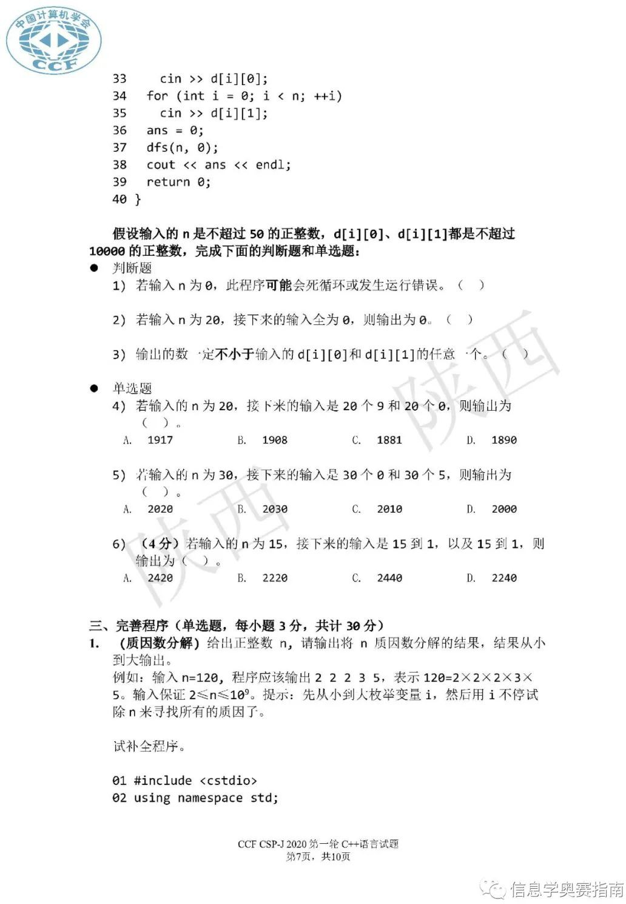

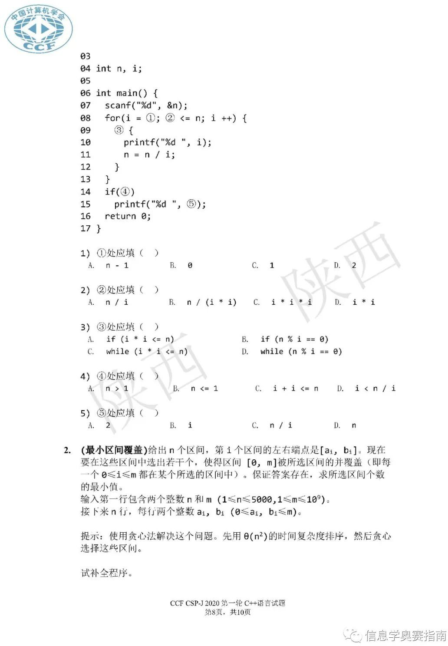

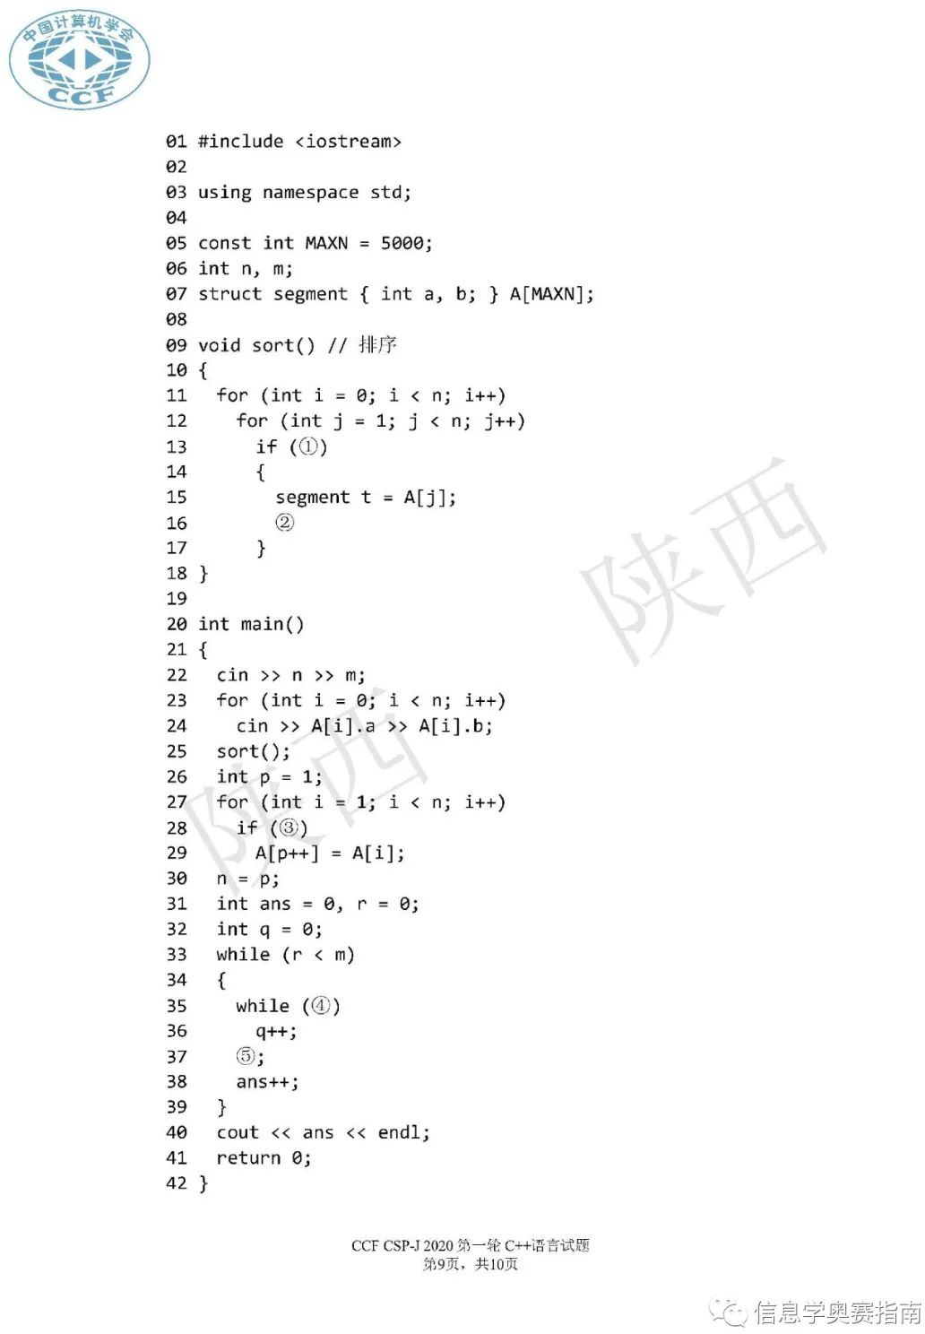

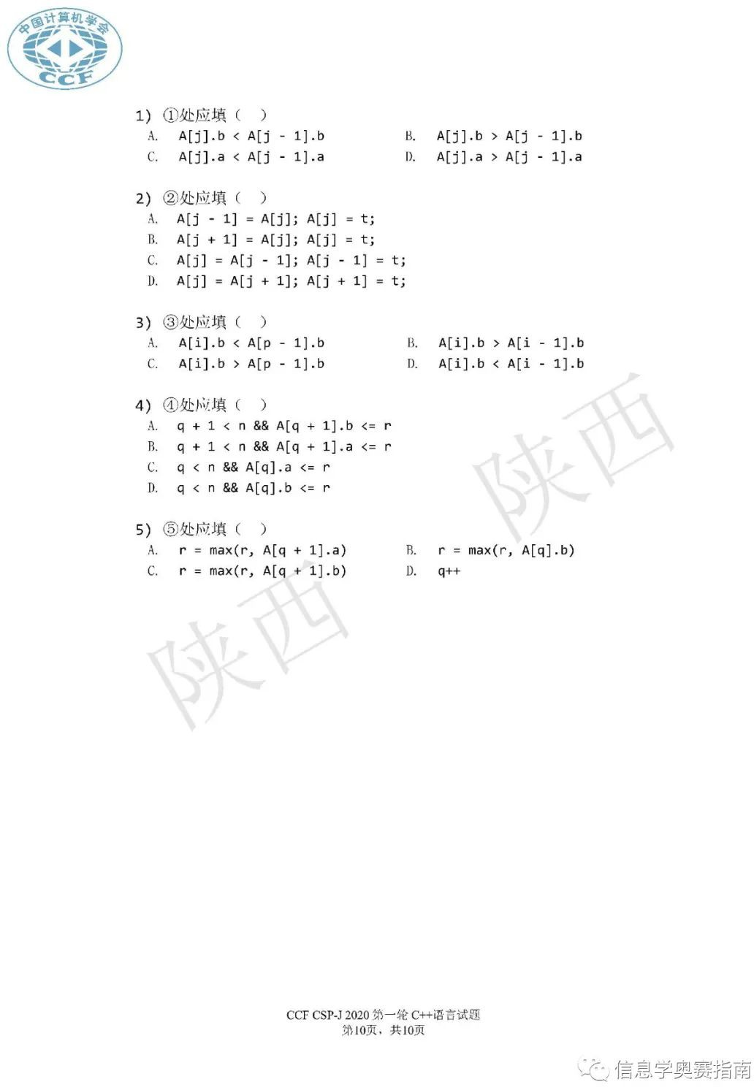

# CSP-J1 参考答案

单项选择

AADCC BAAAA ADCAA

阅读程序

1）√ × √ × A D

1. × × √ D B D
2. × √ × B C C

完善程序

CCCAC BDAAB

# CSP-S1 参考答案

单项选择

CBBBD BAACC CDBDC

阅读程序

1.× × √ √ C C

1. × √ 都对 B A D
2. √ × × D D C

完善程序

DBDDB DBCAB

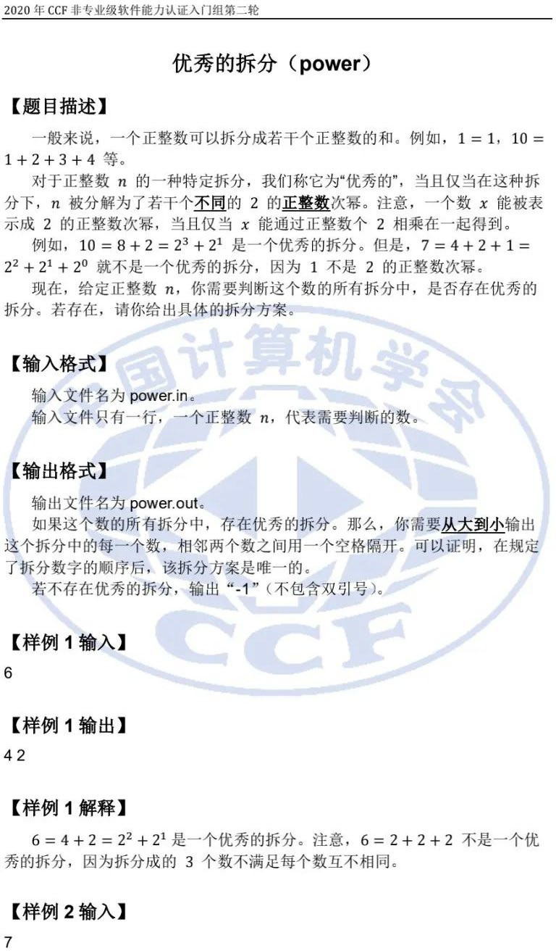CSP-J 2020 入门级第二轮试题

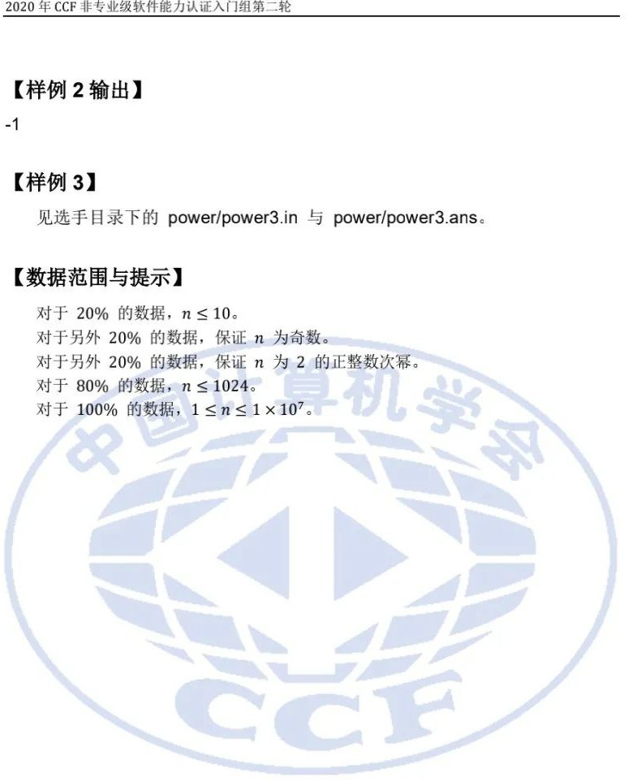

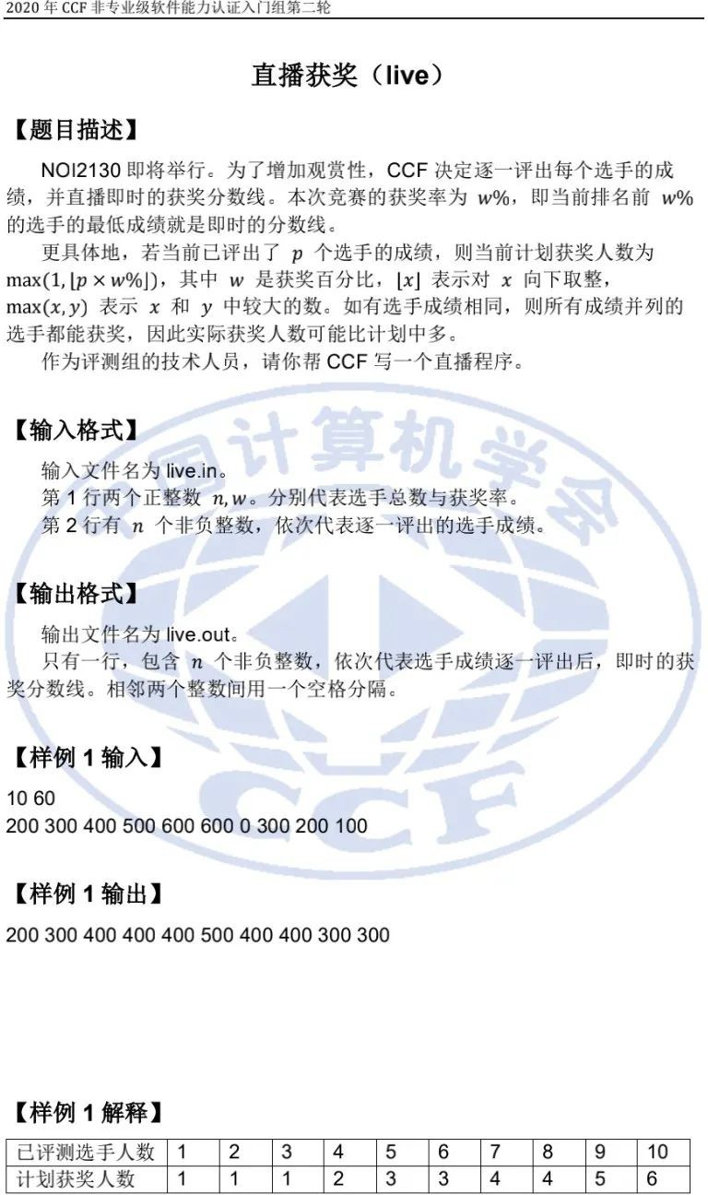

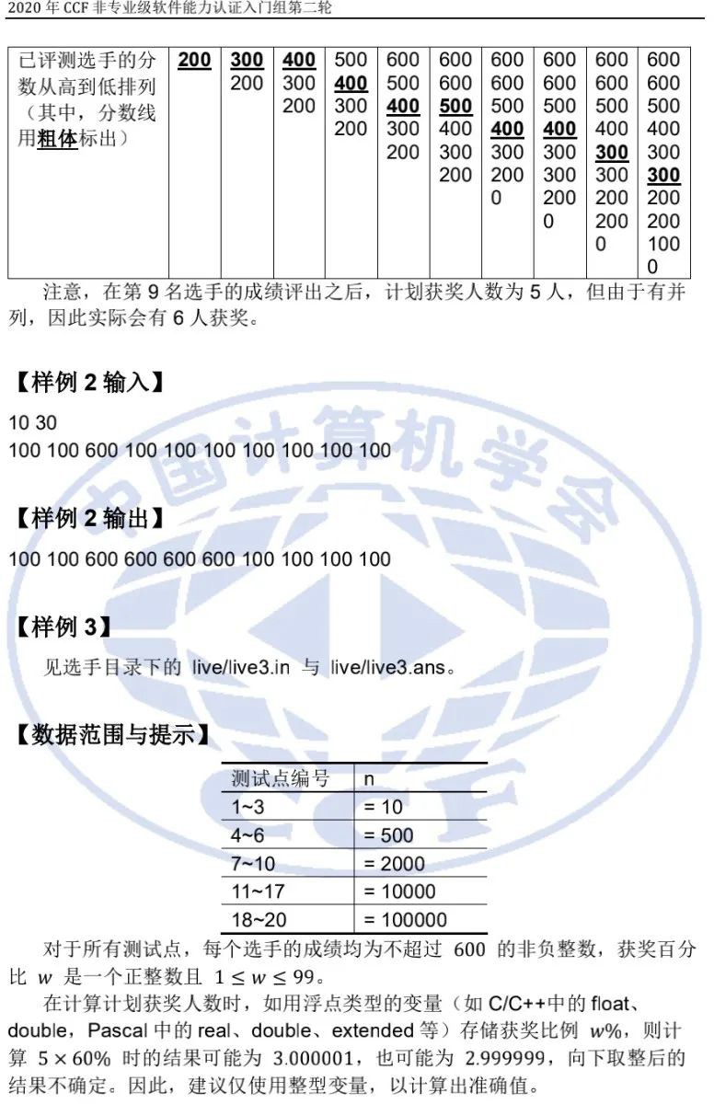

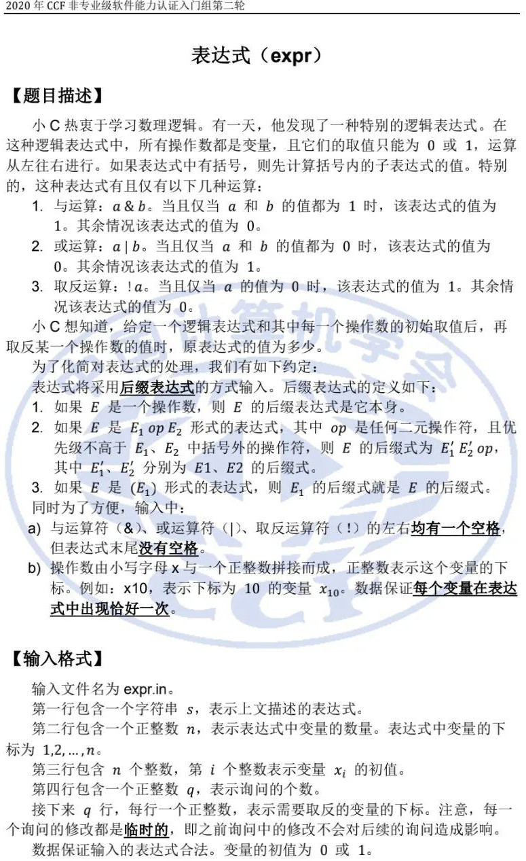

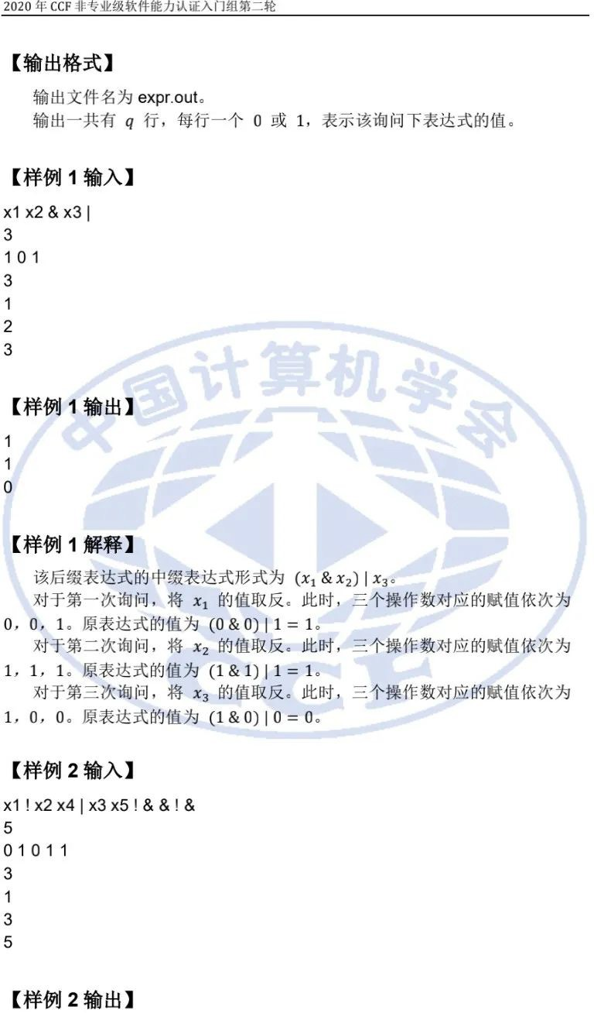

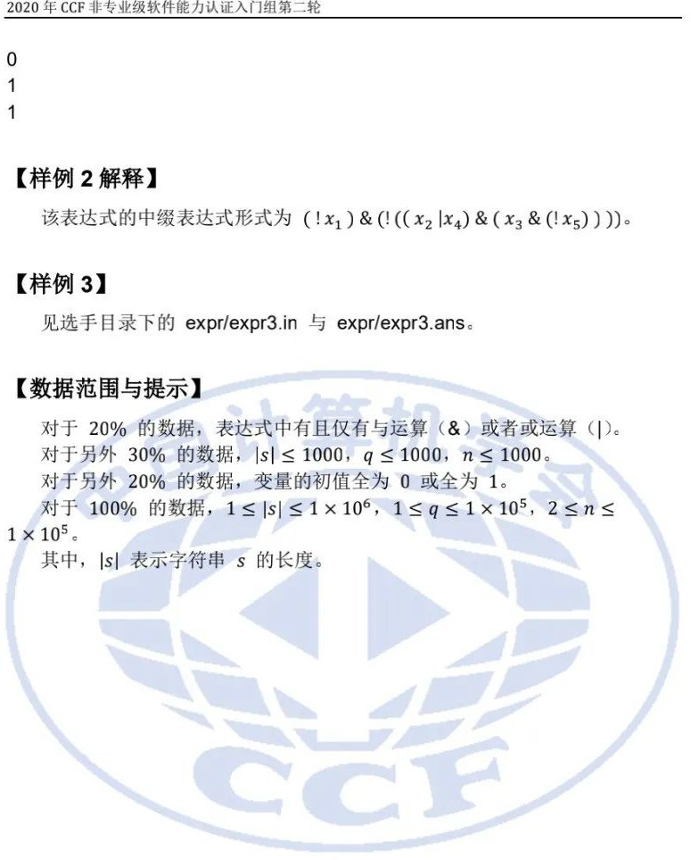

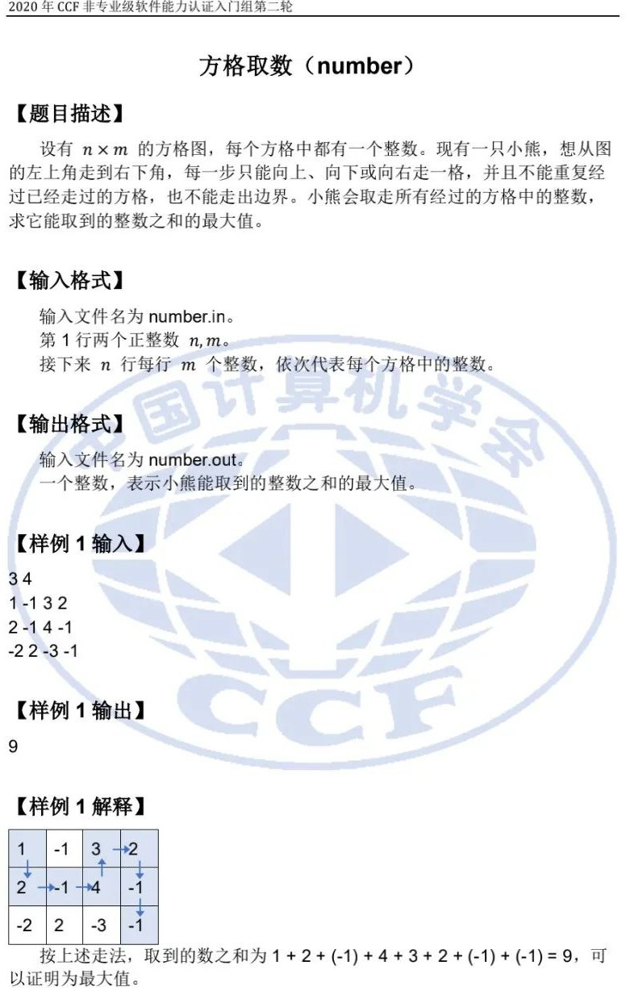

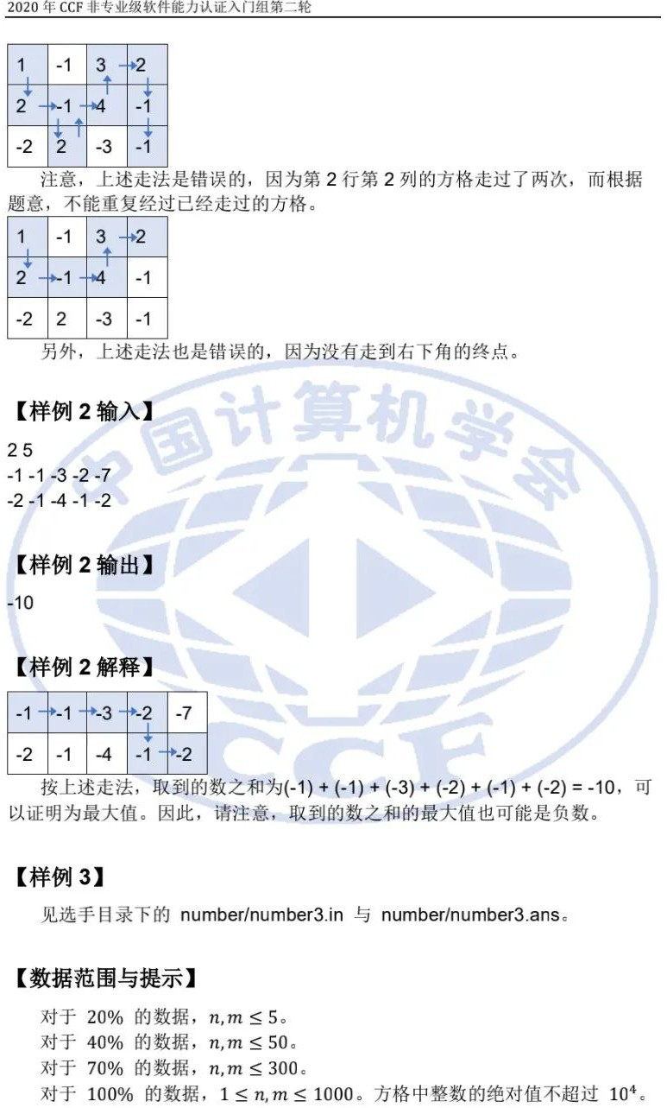

CSP-S 2020 提高级第二轮试题

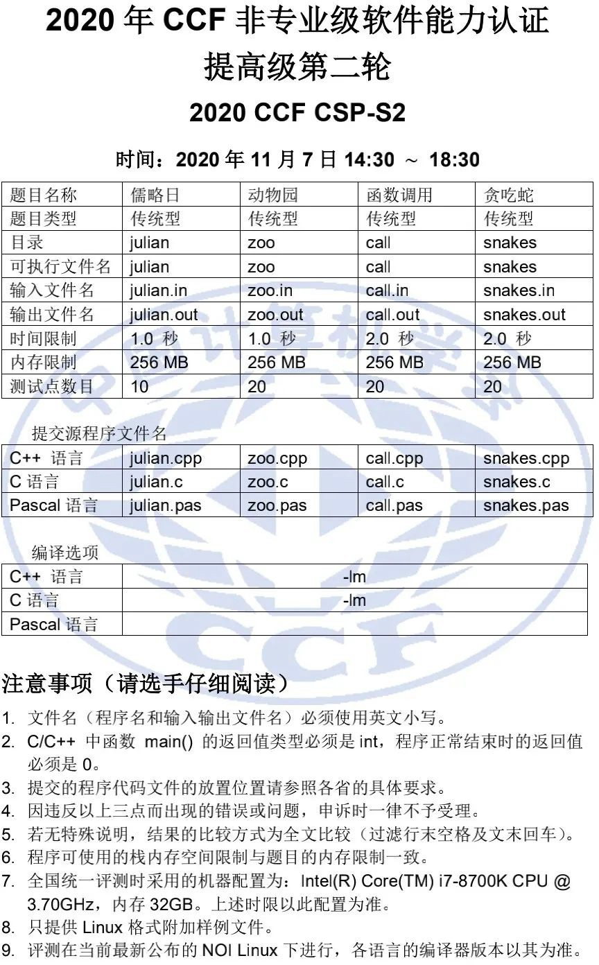

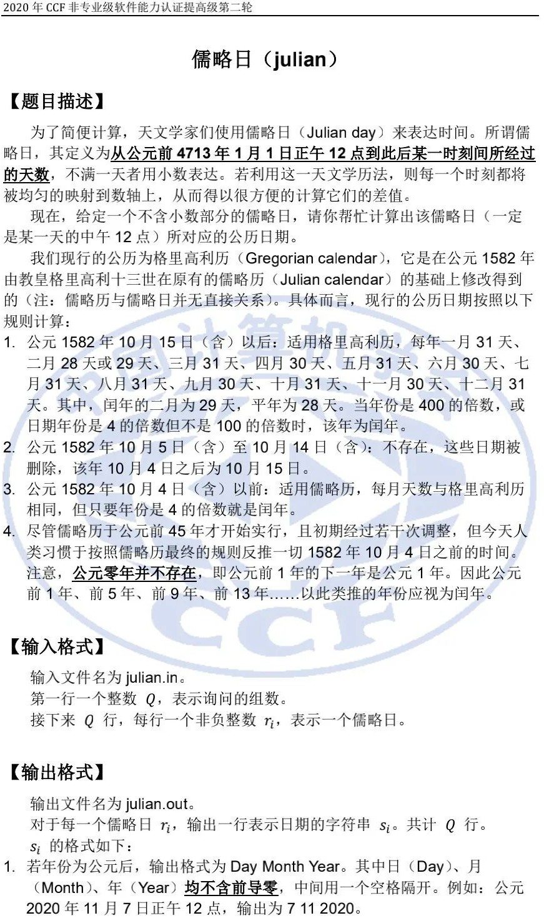

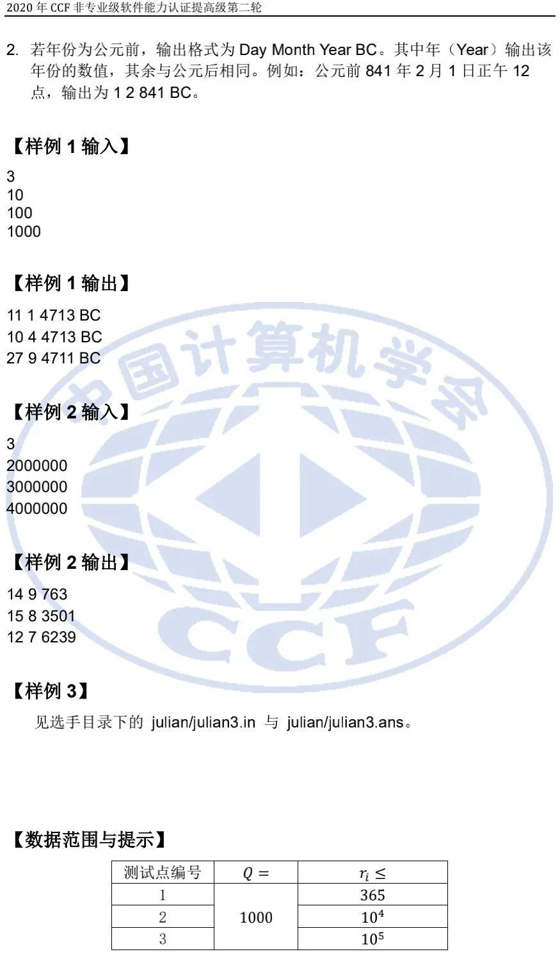

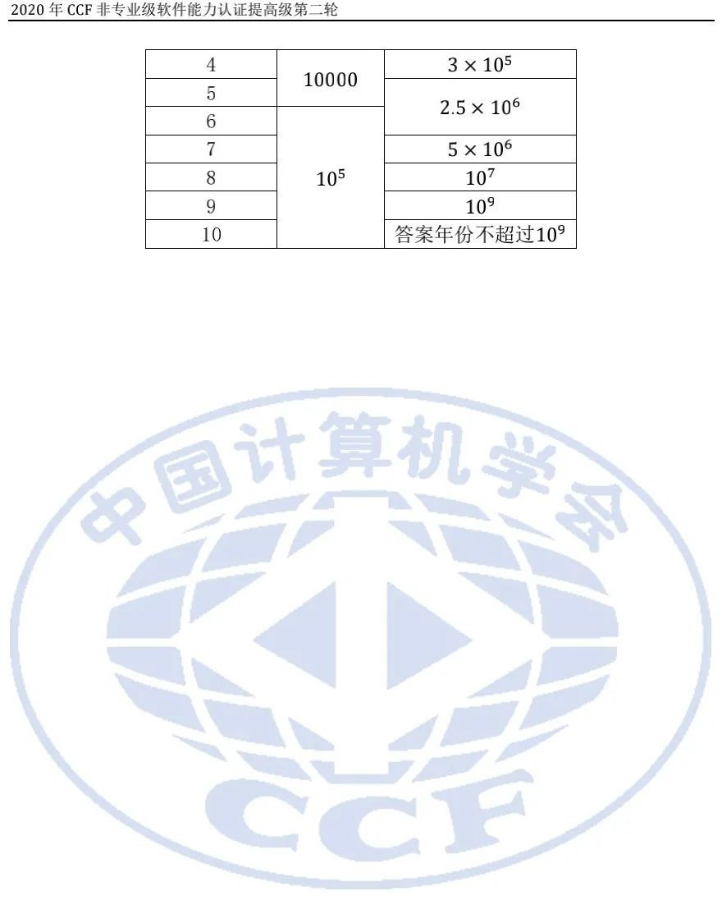

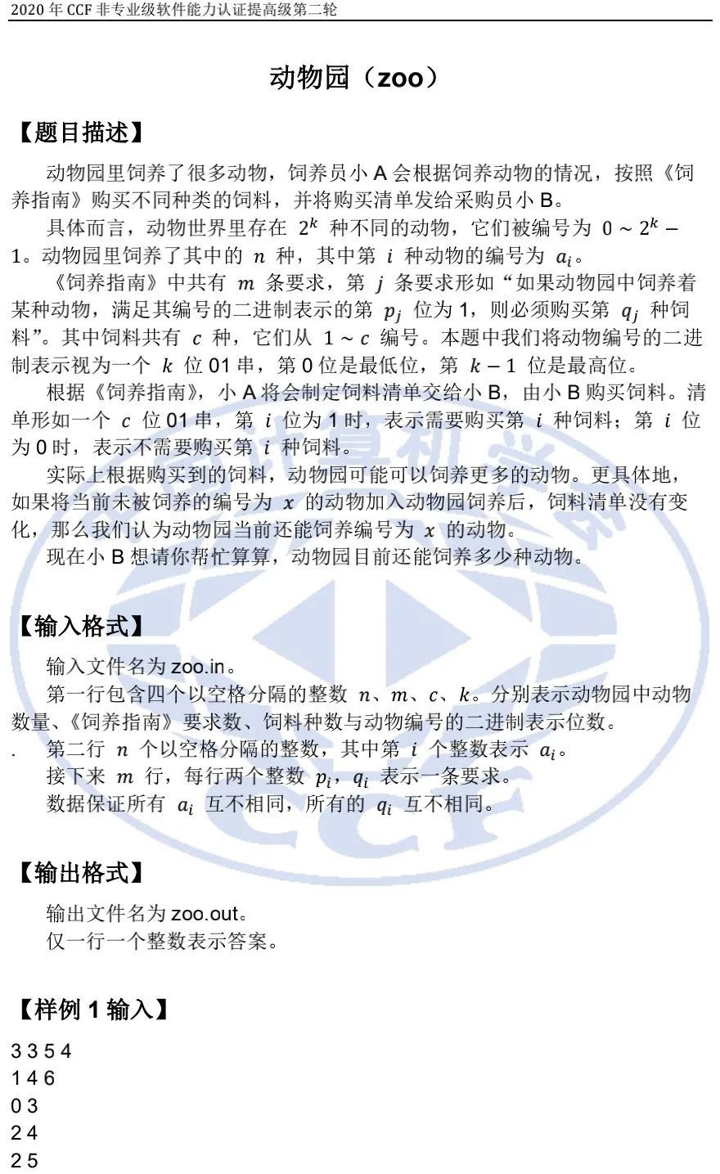

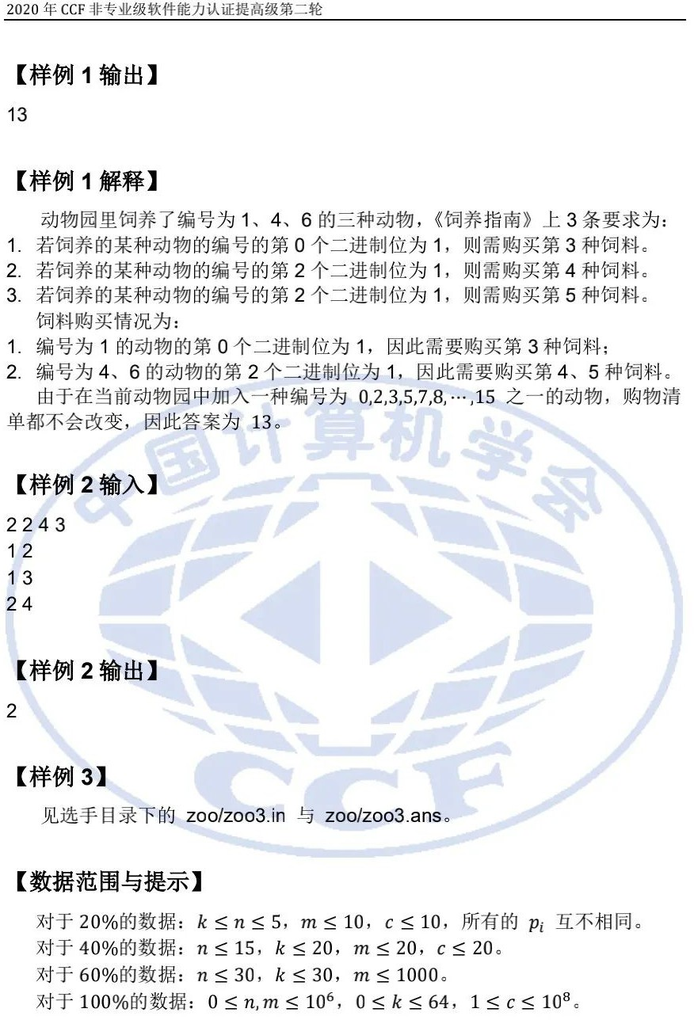

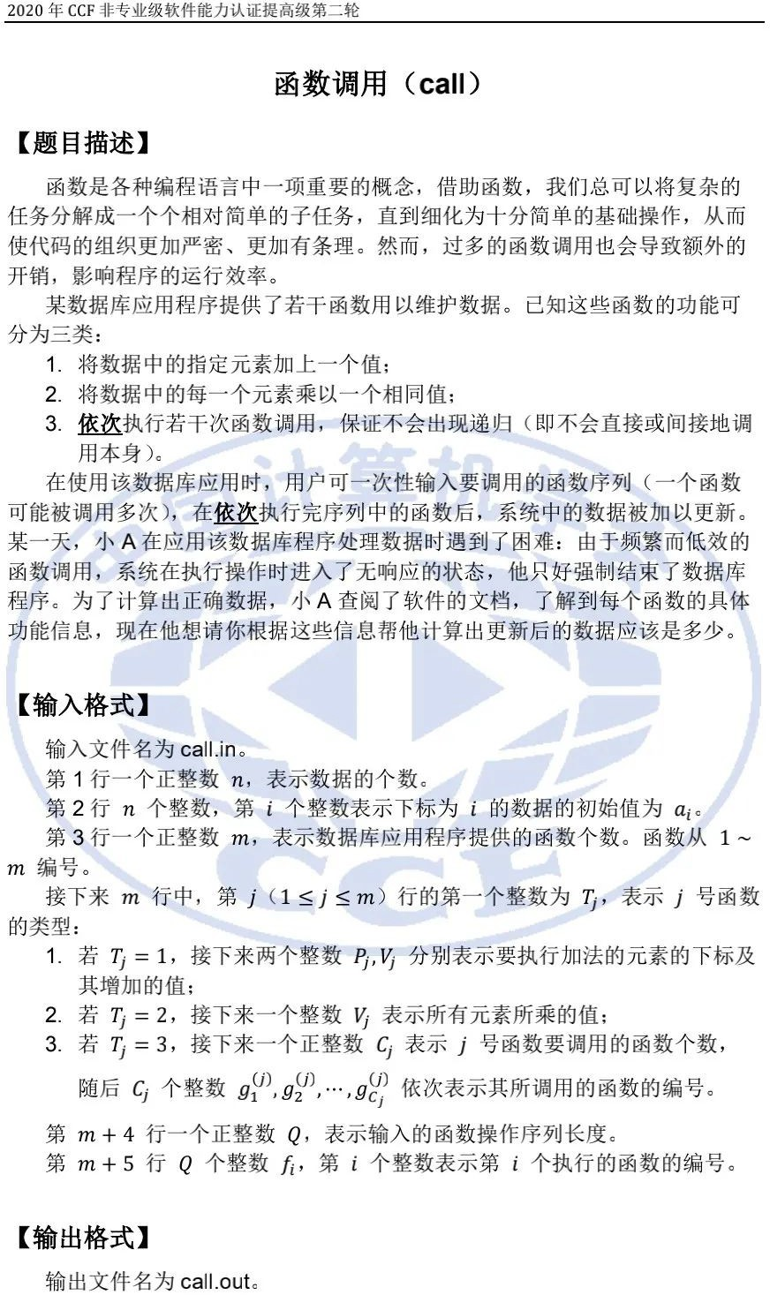

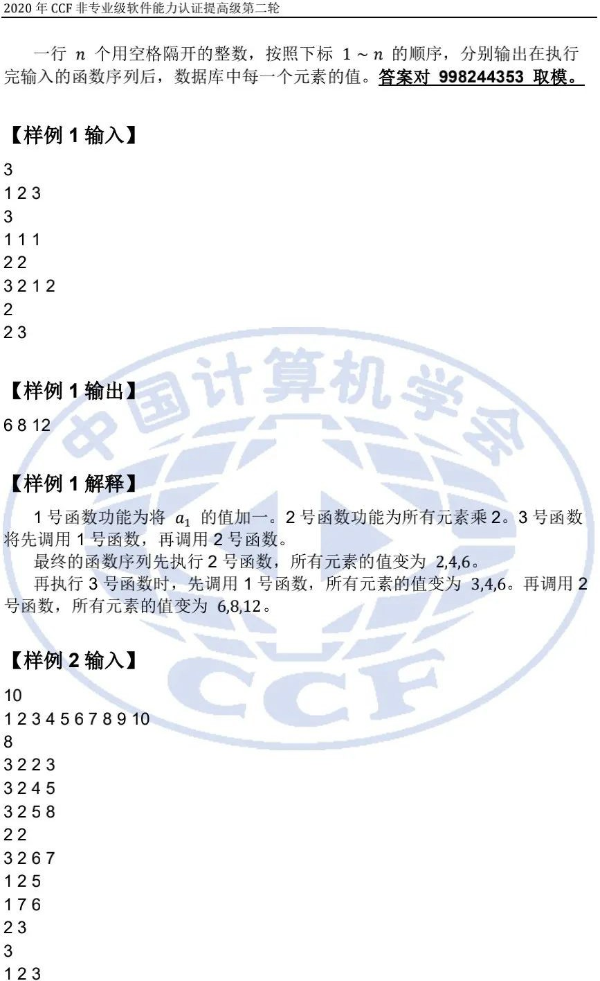

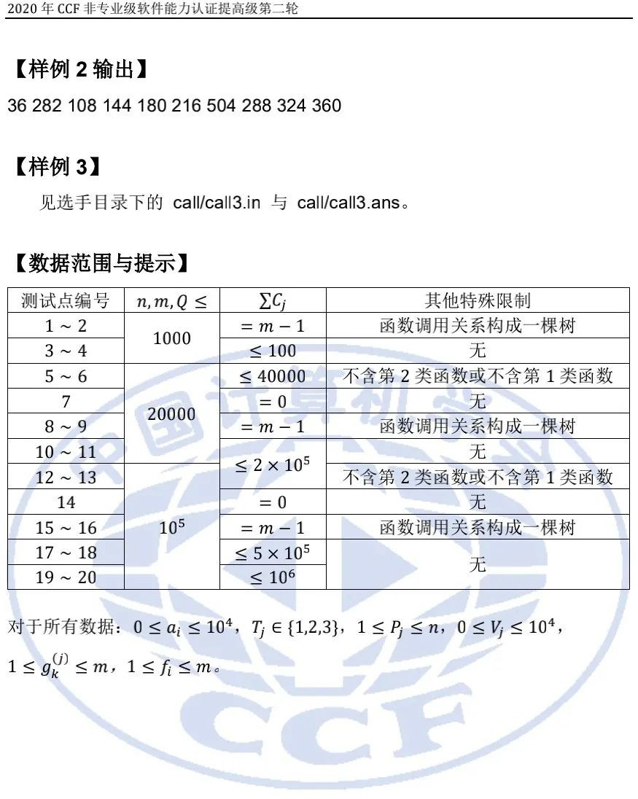

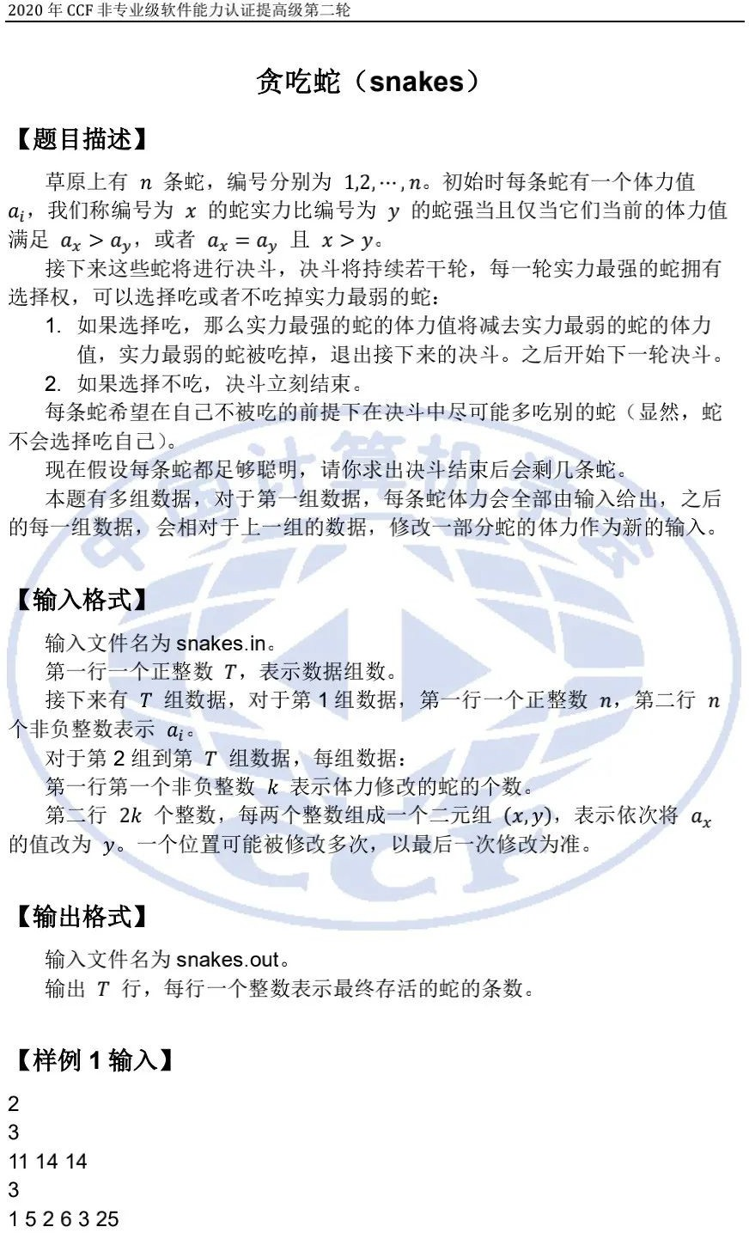

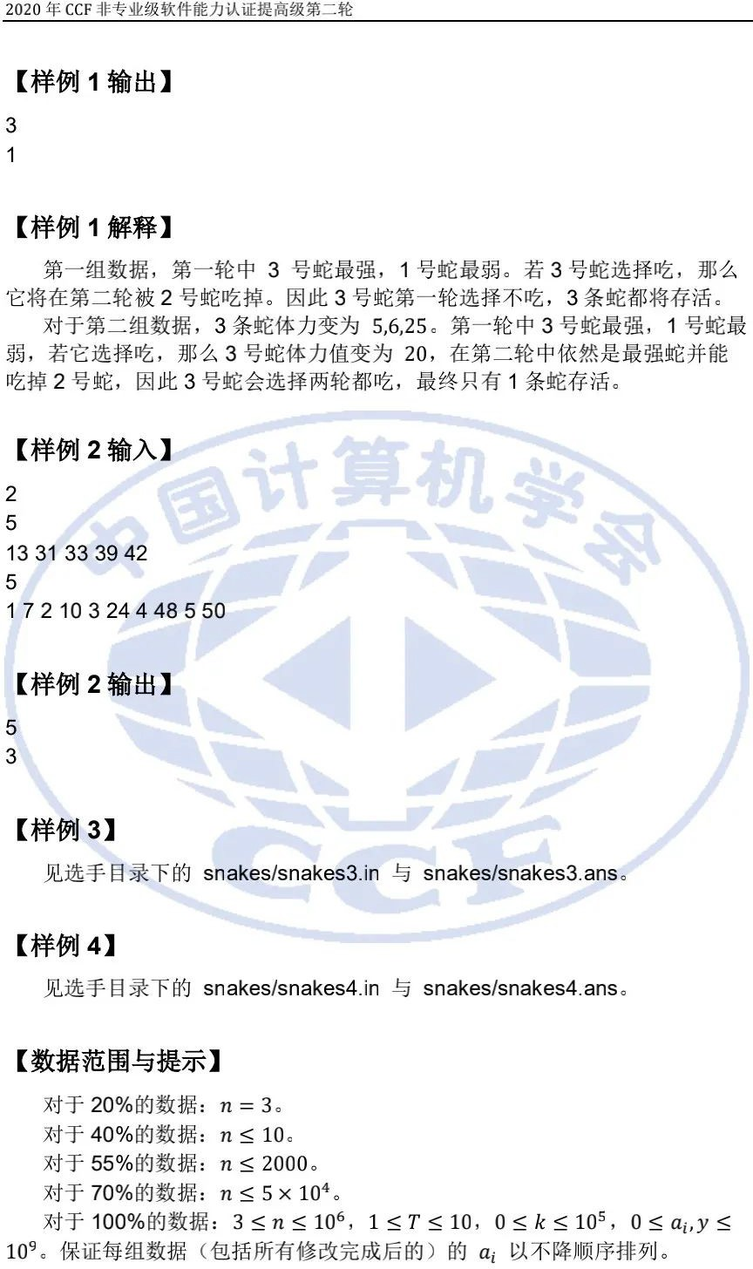

NOIP 2020 在线模拟赛试题与题解

信奥题库 NOIP 2020 在线模拟赛已于 11 月 28 日顺利举行，现公开模拟赛试题、参考标程与题解，供各位选手参考。

**A 题：有趣的函数**

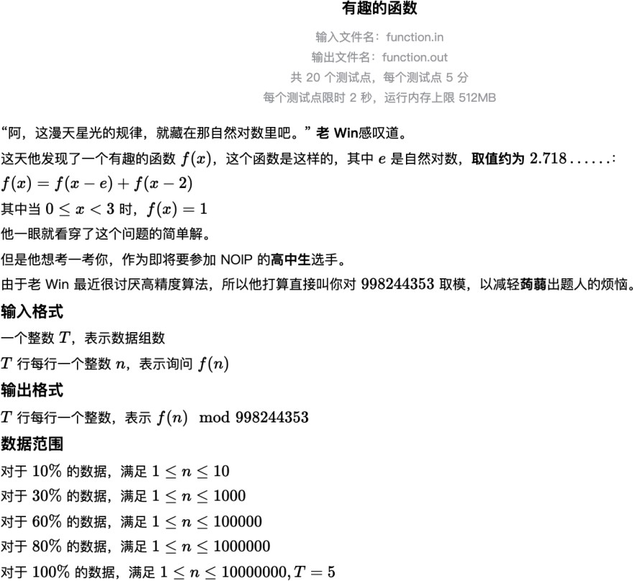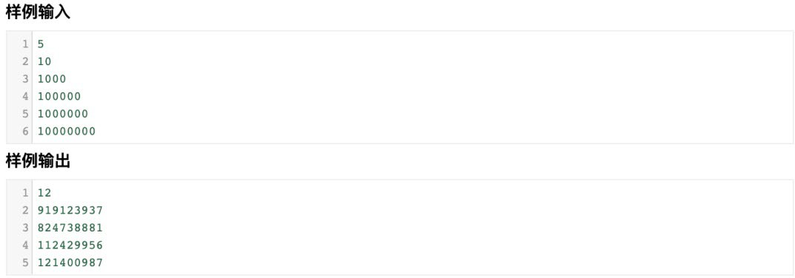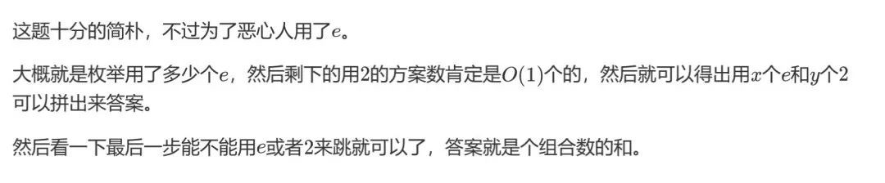

**题解**

**参考标程**

#include <bits/stdc++.h> using namespace std;

const int N = 10000010; int T, n;

int fac[N], inv[N]; double e = exp(1); const int mod = 998244353;

int ksm(int x, int t)

{

int tot = 1; while (t) {

if (t & 1) tot = 1ll * tot * x % mod; x = 1ll * x * x % mod;

t /= 2;

}

return tot;

}

void ad(int& x, int y) { x = (x + y >= mod) ? (x + y - mod) : (x + y); }

int C(int x, int y) { return 1ll * fac[x] * inv[x - y] % mod * inv[y] % mod; }

int main()

{

freopen("A.in", "r", stdin);

freopen("A.out", "w", stdout); scanf("%d", &T);

n = 10000000;

fac[0] = 1;

for (int i = 1; i <= n; i++) fac[i] = 1ll * fac[i - 1] * i % mod; inv[n] = ksm(fac[n], mod - 2);

for (int i = n - 1; i >= 0; i--) inv[i] = 1ll * inv[i + 1] * (i + 1) % mod;

while (T--) {

scanf("%d", &n); if (n < 3) {

printf("1\n"); continue;

}

int ans = 0;

for (int i = 0; i * e <= n; i++)

for (int j = max((int)floor((n - i * e - 3) / 2), 0); j * 2 + i * e <= n; j++) { if (n - i * e - j * 2 >= 3) continue;

if (n - i * e - (j - 1) * 2 >= 3 && j) ad(ans, C(i + j - 1, j - 1));

if (n - (i - 1) * e - j * 2 >= 3 && i) ad(ans, C(i + j - 1, i - 1));

}

printf("%d\n", ans);

}

}

**B 题：能量球**

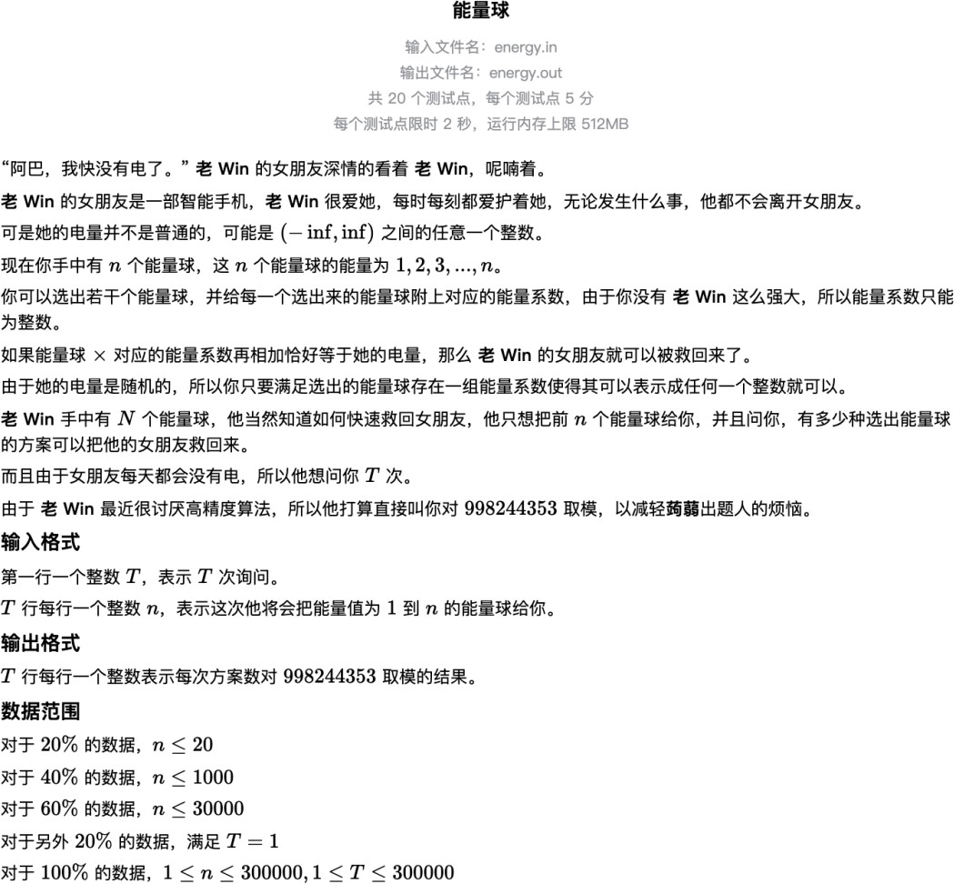

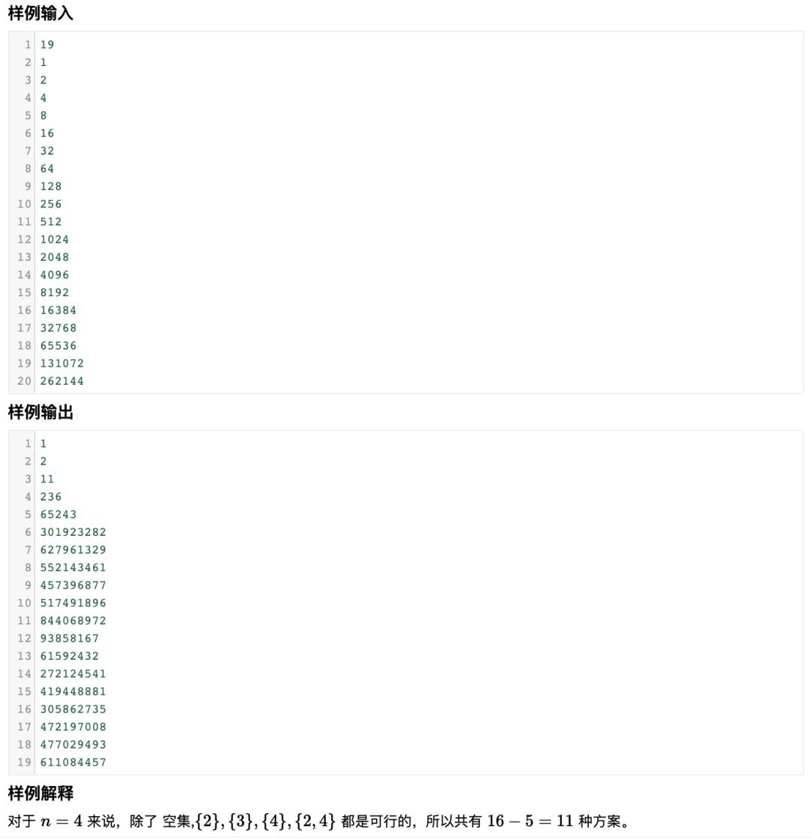

**题解**

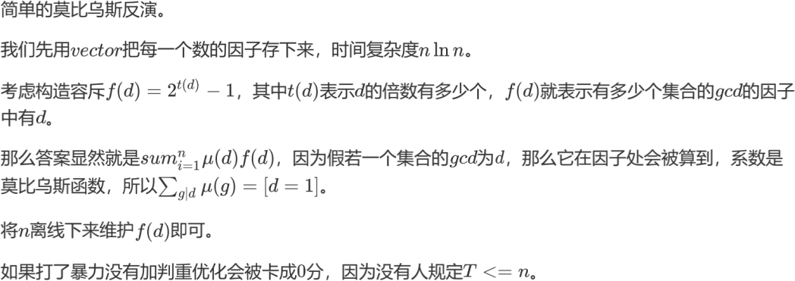

**参考标程**

#include <bits/stdc++.h> using namespace std;

const int N = 300010; vector<int> V[N];

int mu[N], p[N], Ans[N], T, n, t[N], ci[N], ans; bool vis[N];

const int mod = 998244353;

void read(int& x)

{

char ch = getchar(); x = 0;

while (ch < '0' || ch > '9') ch = getchar();

while (ch >= '0' && ch <= '9') x = x * 10 + ch - '0', ch = getchar();

}

void ad(int& x, int y) { x = (x + y >= mod) ? (x + y - mod) : (x + y); }

void ins(int x) { ad(ans, 1ll * mu[x] * ci[t[x]] % mod), t[x]++; }

int main()

{

freopen("B.in", "r", stdin);

freopen("B.out", "w", stdout);

read(T);

n = 300000;

mu[1] = 1;

for (int i = 2; i <= n; i++) {

if (!vis[i]) p[++p[0]] = i, mu[i] = mod - 1;

for (int j = 1; j <= p[0] && 1ll * i * p[j] <= n; j++) { vis[i * p[j]] = true;

if (i % p[j] == 0) break; if (mu[i] == 0)

mu[i * p[j]] = 0;

else

mu[i * p[j]] = mod - mu[i];

}

}

ci[0] = 1;

for (int i = 1; i <= n; i++) ci[i] = ci[i - 1], ad(ci[i], ci[i - 1]); for (int i = 1; i <= n; i++)

if (mu[i])

for (int j = i; j <= n; j += i) V[j].push_back(i); for (int i = 1; i <= n; i++) {

for (int j = 0; j < V[i].size(); j++) ins(V[i][j]); Ans[i] = ans;

}

while (T--) read(n), printf("%d\n", Ans[n]);

}

**C 题：修剪树枝**

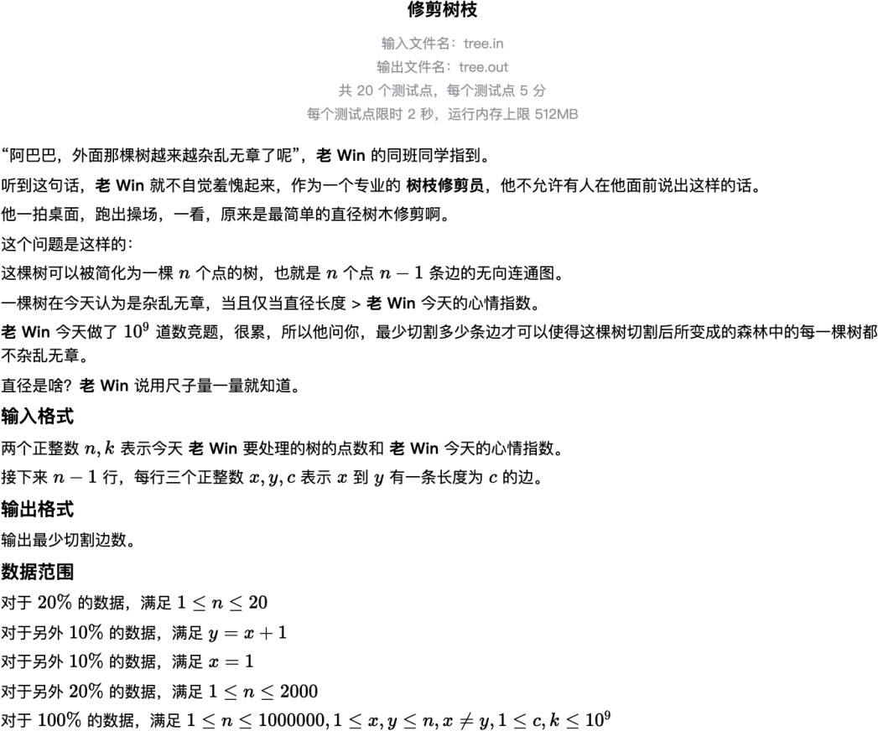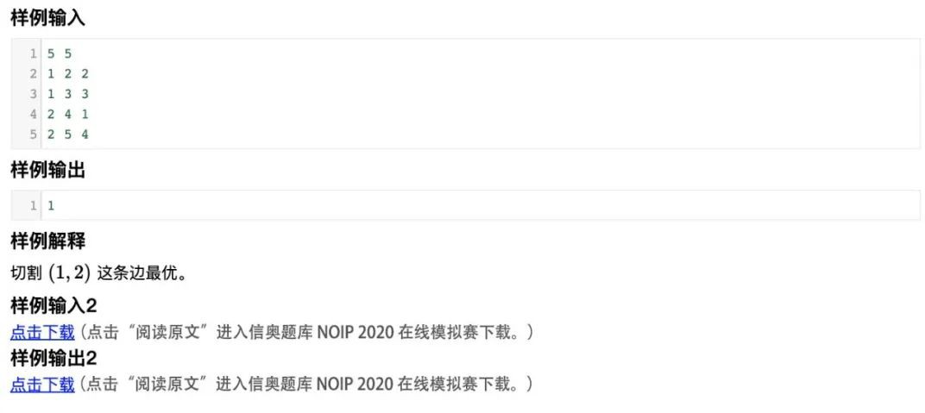

**题解**

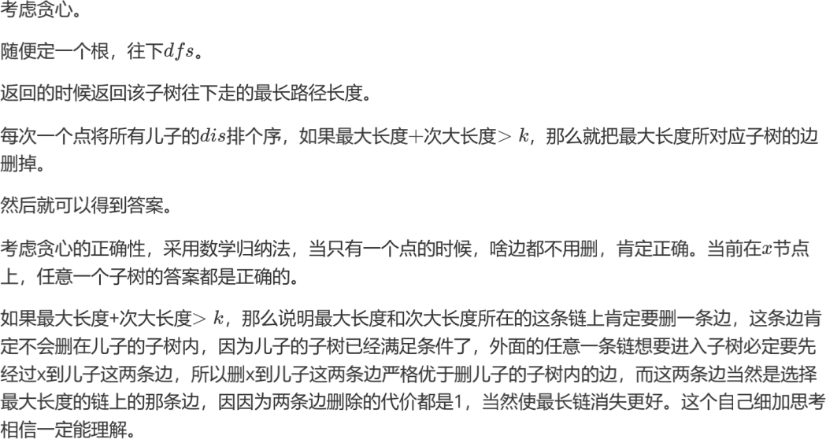

**参考标程**

#include <bits/stdc++.h>

using namespace std;

const int N = 1000010;

struct edge {

int y, nex, c;

} s[N << 1];

int first[N], len, n, m; int ans = 0;

void read(int& x)

{

char ch = getchar(); x = 0;

while (ch < '0' || ch > '9') ch = getchar();

while (ch >= '0' && ch <= '9') x = x * 10 + ch - '0', ch = getchar();

}

void ins(int x, int y, int c)

{

s[++len] = (edge){y, first[x], c}; first[x] = len;

}

int dfs(int x, int fa)

{

vector<int> V;

for (int i = first[x]; i != 0; i = s[i].nex)

if (s[i].y != fa) V.push_back(dfs(s[i].y, x) + s[i].c); sort(V.begin(), V.end());

for (int i = V.size() - 1; i >= 0; i--) {

if (V[i] > m || i && V[i] > m - V[i - 1]) ans++;

else

return V[i];

}

return 0;

}

int main()

{

freopen("C.in", "r", stdin);

freopen("C.out", "w", stdout); read(n);

read(m);

int x, y, c;

for (int i = 1; i < n; i++) read(x), read(y), read(c), ins(x, y, c), ins(y, x, c); dfs(1, 0);

printf("%d", ans);

}

**D 题：三元组**

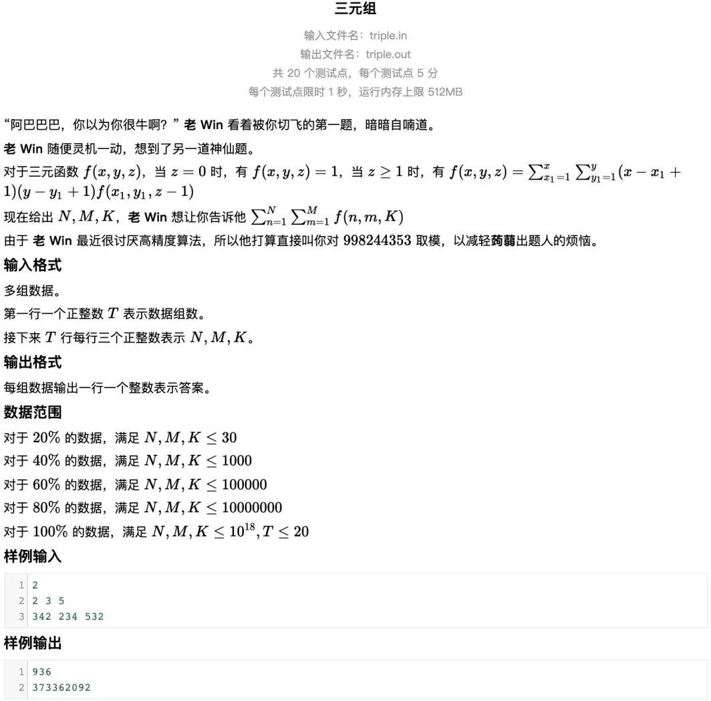

**题解**

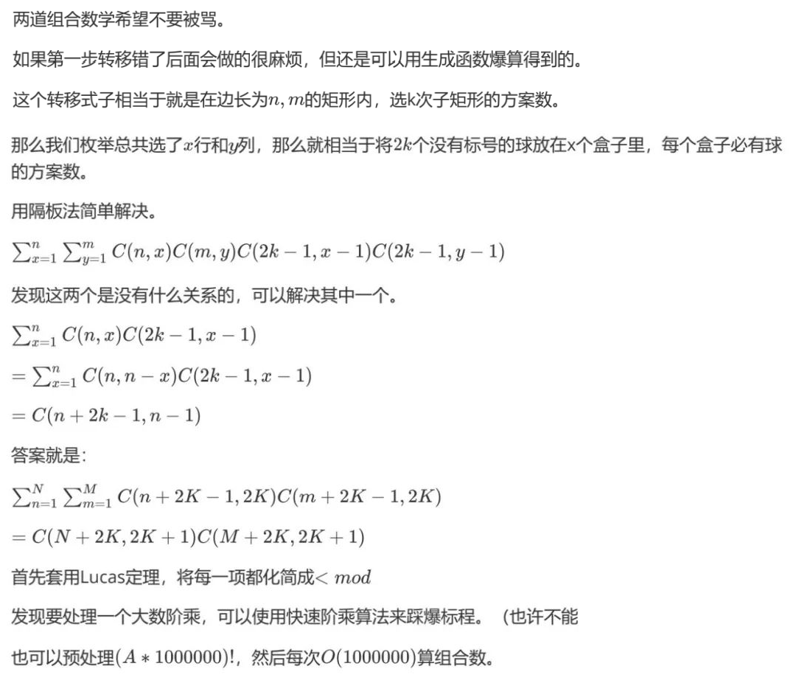

**参考标程**

#include <bits/stdc++.h>

using namespace std;

int pre[1000010] = {

|  |  |  |  |  |  |  |  |  |  |
| --- | --- | --- | --- | --- | --- | --- | --- | --- | --- |
| 1, | 373341033, | 45596018, | 834980587, | 623627864, | 428937595, | 442819817, | 499710224, | 833655840, | 83857087, |
| 295201906, | 788488293, | 671639287, | 849315549, | 597398273, | 813259672, | 732727656, | 244038325, | 122642896, | 310517972, |
| 160030060, | 483239722, | 683879839, | 712910418, | 384710263, | 433880730, | 844360005, | 513089677, | 101492974, | 959253371, |
| 957629942, | 678615452, | 34035221, | 56734233, | 524027922, | 31729117, | 102311167, | 330331487, | 8332991, | 832392662, |
| 545208507, | 594075875, | 318497156, | 859275605, | 300738984, | 767818091, | 864118508, | 878131539, | 316588744, | 812496962, |
| 213689172, | 584871249, | 980836133, | 54096741, | 417876813, | 363266670, | 335481797, | 730839588, | 393495668, | 435793297, |
| 760025067, | 811438469, | 720976283, | 650770098, | 586537547, | 117371703, | 566486504, | 749562308, | 708205284, | 932912293, |
| 939830261, | 983699513, | 206579820, | 301188781, | 593164676, | 770845925, | 247687458, | 41047791, | 266419267, | 937835947, |
| 506268060, | 6177705, | 936268003, | 166873118, | 443834893, | 328979964, | 470135404, | 954410105, | 117565665, | 832761782, |
| 39806322, | 478922755, | 394880724, | 821825588, | 468705875, | 512554988, | 232240472, | 876497899, | 356048018, | 895187265, |
| 808258749, | 575505950, | 68190615, | 939065335, | 552199946, | 694814243, | 385460530, | 529769387, | 640377761, | 916128300, |
| 440133909, | 362216114, | 826373774, | 502324157, | 457648395, | 385510728, | 904737188, | 78988746, | 454565719, | 623828097, |
| 686156489, | 713476044, | 63602402, | 570334625, | 681055904, | 222059821, | 477211096, | 343363294, | 833792655, | 461853093, |
| 741797144, | 74731896, | 930484262, | 268372735, | 941222802, | 677432735, | 474842829, | 700451655, | 400176109, | 697644778, |
| 390377694, | 790010794, | 360642718, | 505712943, | 946647976, | 339045014, | 715797300, | 251680896, | 70091750, | 40517433, |
| 12629586, | 850635539, | 110877109, | 571935891, | 695965747, | 634938288, | 69072133, | 155093216, | 749696762, | 963086402, |
| 544711799, | 724471925, | 334646013, | 574791029, | 722417626, | 377929821, | 743946412, | 988034679, | 405207112, | 18063742, |
| 104121967, | 638607426, | 607304611, | 751377777, | 35834555, | 313632531, | 18058363, | 656121134, | 40763559, | 562910912, |
| 495867250, | 48767038, | 210864657, | 659137294, | 715390025, | 865854329, | 324322857, | 388911184, | 286059202, | 636456178, |
| 421290700, | 832276048, | 726437551, | 526417714, | 252522639, | 386147469, | 674313019, | 274769381, | 226519400, | 272047186, |
| 117153405, | 712896591, | 486826649, | 119444874, | 338909703, | 18536028, | 41814114, | 245606459, | 140617938, | 250512392, |
| 57084755, | 157807456, | 261113192, | 40258068, | 194807105, | 325341339, | 884328111, | 896332013, | 880836012, | 737358206, |
| 202713771, | 785454372, | 399586250, | 485457499, | 640827004, | 546969497, | 749602473, | 159788463, | 159111724, | 218592929, |
| 675932866, | 314795475, | 811539323, | 246883213, | 696818315, | 759880589, | 4302336, | 353070689, | 477909706, | 559289160, |
| 79781699, | 878094972, | 840903973, | 367416824, | 973366814, | 848259019, | 462421750, | 667227759, | 897917455, | 81800722, |
| 956276337, | 942686845, | 420541799, | 417005912, | 272641764, | 941778993, | 217214373, | 192220616, | 267901132, | 50530621, |
| 652678397, | 354880856, | 164289049, | 781023184, | 105376215, | 315094878, | 607856504, | 733905911, | 457743498, | 992735713, |
| 35212756, | 231822660, | 276036750, | 734558079, | 424180850, | 433186147, | 308380947, | 18333316, | 12935086, | 351491725, |
| 655645460, | 535812389, | 521902115, | 67016984, | 48682076, | 64748124, | 489360447, | 361275315, | 786336279, | 805161272, |
| 468129309, | 645091350, | 887284732, | 913004502, | 358814684, | 281295633, | 328970139, | 395955130, | 164840186, | 820902807, |

|  |  |  |  |  |  |  |  |  |  |
| --- | --- | --- | --- | --- | --- | --- | --- | --- | --- |
| 761699708, | 246274415, | 592331769, | 913846362, | 866682684, | 600130702, | 903837674, | 529462989, | 90612675, | 526540127, |
| 533047427, | 110008879, | 674279751, | 801920753, | 645226926, | 676886948, | 752481486, | 474034007, | 457790341, | 166813684, |
| 287671032, | 188118664, | 244731384, | 404032157, | 269766986, | 423996017, | 182948540, | 356801634, | 737863144, | 652014069, |
| 206068022, | 504569410, | 919894484, | 593398649, | 963768176, | 882517476, | 702523597, | 949028249, | 128957299, | 171997372, |
| 50865043, | 20937461, | 690959202, | 581356488, | 369182214, | 993580422, | 193500140, | 540665426, | 365786018, | 743731625, |
| 144980423, | 979536721, | 773259009, | 617053935, | 247670131, | 843705280, | 30419459, | 985463402, | 261585206, | 237885042, |
| 111276893, | 488166208, | 137660292, | 720784236, | 244467770, | 26368504, | 792857103, | 666885724, | 670313309, | 905683034, |
| 259415897, | 512017253, | 826265493, | 111960112, | 633652060, | 918048438, | 516432938, | 386972415, | 996212724, | 610073831, |
| 444094191, | 72480267, | 665038087, | 11584804, | 301029012, | 723617861, | 113763819, | 778259899, | 937766095, | 535448641, |
| 593907889, | 783573565, | 673298635, | 599533244, | 655712590, | 173350007, | 868198597, | 169013813, | 585161712, | 697502214, |
| 573994984, | 285943986, | 675831407, | 3134056, | 965907646, | 401920943, | 665949756, | 236277883, | 612745912, | 813282113, |
| 892454686, | 901222267, | 624900982, | 927122298, | 686321335, | 84924870, | 927606072, | 506664166, | 353631992, | 165913238, |
| 566073550, | 816674343, | 864877926, | 171259407, | 908752311, | 874007723, | 803597299, | 613676466, | 880336545, | 282280109, |
| 128761001, | 58852065, | 474075900, | 434816091, | 364856903, | 149123648, | 388854780, | 314693916, | 423183826, | 419733481, |
| 888483202, | 238933227, | 336564048, | 757103493, | 100189123, | 855479832, | 51370348, | 403061033, | 496971759, | 831753030, |
| 251718753, | 272779384, | 683379259, | 488844621, | 881783783, | 659478190, | 445719559, | 740782647, | 546525906, | 985524427, |
| 548033568, | 333772553, | 331916427, | 752533273, | 730387628, | 93829695, | 655989476, | 930661318, | 334885743, | 466041862, |
| 428105027, | 888238707, | 232218076, | 769865249, | 730641039, | 616996159, | 231721356, | 326973501, | 426068899, | 722403656, |
| 742756734, | 663270261, | 364187931, | 350431704, | 671823672, | 633125919, | 226166717, | 386814657, | 237594135, | 451479365, |
| 546182474, | 119366536, | 465211069, | 605313606, | 728508871, | 249619035, | 663053607, | 900453742, | 48293872, | 229958401, |
| 62402409, | 69570431, | 71921532, | 960467929, | 537087913, | 514588945, | 513856225, | 415497414, | 286592050, | 645469437, |
| 102052166, | 163298189, | 873938719, | 617583886, | 986843080, | 962390239, | 580971332, | 665147020, | 88900164, | 89866970, |
| 826426395, | 616059995, | 443012312, | 659160562, | 229855967, | 687413213, | 59809521, | 398599610, | 325666688, | 154765991, |
| 159186619, | 210830877, | 386454418, | 84493735, | 974220646, | 820097297, | 2191828, | 481459931, | 729073424, | 551556379, |
| 926316039, | 151357011, | 808637654, | 218058015, | 786112034, | 850407126, | 84202800, | 94214098, | 30019651, | 121701603, |
| 176055335, | 865461951, | 553631971, | 286620803, | 984061713, | 888573766, | 302767023, | 977070668, | 110954576, | 83922475, |
| 51568171, | 60949367, | 19533020, | 510592752, | 615419476, | 341370469, | 912573425, | 286207526, | 206707897, | 384156962, |
| 414163604, | 193301813, | 749570167, | 366933789, | 11470970, | 600191572, | 391667731, | 328736286, | 30645366, | 215162519, |
| 604947226, | 236199953, | 718439098, | 411423177, | 803407599, | 632441623, | 766760224, | 263006576, | 757681534, | 61082578, |
| 681666415, | 947466395, | 12206799, | 659767098, | 933746852, | 978860867, | 59215985, | 161179205, | 439197472, | 259779111, |
| 511621808, | 145770512, | 882749888, | 943124465, | 872053396, | 631078482, | 166861622, | 743415395, | 772287179, | 602427948, |
| 924112080, | 385643091, | 794973480, | 883782693, | 869723371, | 805963889, | 313106351, | 262132854, | 400034567, | 488248149, |

|  |  |  |  |  |  |  |  |  |  |
| --- | --- | --- | --- | --- | --- | --- | --- | --- | --- |
| 265769800, | 791715397, | 408753255, | 468381897, | 415812467, | 172922144, | 64404368, | 281500398, | 512318142, | 288791777, |
| 955559118, | 242484726, | 536413695, | 205340854, | 707803527, | 576699812, | 218525078, | 875554190, | 46283078, | 833841915, |
| 763148293, | 807722138, | 788080170, | 556901372, | 150896699, | 253151120, | 97856807, | 918256774, | 771557187, | 582547026, |
| 472709375, | 911615063, | 743371401, | 641382840, | 446540967, | 184639537, | 157247760, | 775930891, | 939702814, | 499082462, |
| 19536133, | 548753627, | 593243221, | 563850263, | 185475971, | 687419227, | 396799323, | 657976136, | 864535682, | 433009242, |
| 860830935, | 33107339, | 517661450, | 467651311, | 812398757, | 202133852, | 431839017, | 709549400, | 99643620, | 773282878, |
| 290471030, | 61134552, | 129206504, | 929147251, | 837008968, | 422332597, | 353775281, | 469563025, | 62265336, | 835064501, |
| 851685235, | 21197005, | 264793769, | 326416680, | 118842991, | 84257200, | 763248924, | 687559609, | 150907932, | 401832452, |
| 242726978, | 766752066, | 959173604, | 390269102, | 992293822, | 744816299, | 476631694, | 177284763, | 702429415, | 374065901, |
| 169855231, | 629007616, | 719169602, | 564737074, | 475119050, | 714502830, | 40993711, | 820235888, | 749063595, | 239329111, |
| 612759169, | 18591377, | 419142436, | 442202439, | 941600951, | 158013406, | 637073231, | 471564060, | 447222237, | 701248503, |
| 599797734, | 577221870, | 69656699, | 51052704, | 6544303, | 10958310, | 554955500, | 943192237, | 192526269, | 897983911, |
| 961628039, | 240232720, | 627280533, | 710239542, | 70255649, | 261743865, | 228474833, | 776408079, | 304180483, | 63607040, |
| 953297493, | 758058902, | 395529997, | 156010331, | 825833840, | 539880795, | 234683685, | 52626619, | 751843490, | 116909119, |
| 62806842, | 574857555, | 353417551, | 40061330, | 822203768, | 681051568, | 490913702, | 9322961, | 766631257, | 124794668, |
| 37844313, | 163524507, | 729108319, | 490867505, | 47035168, | 682765157, | 53842115, | 817965276, | 757179922, | 339238384, |
| 909741023, | 150530547, | 158444563, | 140949492, | 993302799, | 551621442, | 137578883, | 475122706, | 443869843, | 605400098, |
| 689361523, | 769596520, | 801661499, | 474900284, | 586624857, | 349960501, | 134084537, | 650564083, | 877097974, | 379857427, |
| 887890124, | 159436401, | 133274277, | 986182139, | 729720334, | 568925901, | 459461496, | 499309445, | 493171177, | 460958750, |
| 380694152, | 168836226, | 840160881, | 141116880, | 225064950, | 109618190, | 842341383, | 85305729, | 759273275, | 97369807, |
| 669317759, | 766247510, | 829017039, | 550323884, | 261274540, | 918239352, | 29606025, | 870793828, | 293683814, | 378510746, |
| 367270918, | 481292028, | 813097823, | 798448487, | 230791733, | 899305835, | 504040630, | 162510533, | 479367951, | 275282274, |
| 806951470, | 462774647, | 56473153, | 184659008, | 905122161, | 664034750, | 109726629, | 59372704, | 325795100, | 486860143, |
| 843736533, | 924723613, | 880348000, | 801252478, | 616515290, | 776142608, | 284803450, | 583439582, | 274826676, | 6018349, |
| 377403437, | 244041569, | 527081707, | 544763288, | 708818585, | 354033051, | 904309832, | 589922898, | 673933870, | 682858433, |
| 945260111, | 899893421, | 515264973, | 911685911, | 9527148, | 239480646, | 524126897, | 48259065, | 578214879, | 118677219, |
| 786127243, | 869205770, | 923276513, | 937928886, | 802186160, | 12198440, | 638784295, | 34200904, | 758925811, | 185027790, |
| 80918046, | 120604699, | 610456697, | 573601211, | 208296321, | 49743354, | 653691911, | 490750754, | 674335312, | 887877110, |
| 875880304, | 308360096, | 414636410, | 886100267, | 8525751, | 636257427, | 558338775, | 500159951, | 696213291, | 97268896, |
| 364983542, | 937928436, | 641582714, | 586211304, | 345265657, | 994704486, | 443549763, | 207259440, | 302122082, | 166055224, |
| 623250998, | 239642551, | 476337075, | 283167364, | 211328914, | 68064804, | 950202136, | 187552679, | 18938709, | 646784245, |
| 598764068, | 538505481, | 610424991, | 864445053, | 390248689, | 278395191, | 686098470, | 935957187, | 868529577, | 329970687, |

|  |  |  |  |  |  |  |  |  |  |
| --- | --- | --- | --- | --- | --- | --- | --- | --- | --- |
| 804930040, | 84992079, | 474569269, | 810762228, | 573258936, | 756464212, | 155080225, | 286966169, | 283614605, | 19283401, |
| 24257676, | 871831819, | 612689791, | 846988741, | 617120754, | 971716517, | 979541482, | 297910784, | 991087897, | 783825907, |
| 214821357, | 689498189, | 405026419, | 946731704, | 609346370, | 707669156, | 457703127, | 957341187, | 980735523, | 649367684, |
| 791011898, | 82098966, | 234729712, | 105002711, | 130614285, | 291032164, | 193188049, | 363211260, | 58108651, | 100756444, |
| 954947696, | 346032213, | 863300806, | 36876722, | 622610957, | 289232396, | 667938985, | 734886266, | 395881057, | 417188702, |
| 183092975, | 887586469, | 83334648, | 797819763, | 100176902, | 781587414, | 841864935, | 371674670, | 18247584}; |  |

const int mod = 998244353;

int ksm(int x, int t)

{

int tot = 1; while (t) {

if (t & 1) tot = 1ll * tot * x % mod; x = 1ll * x * x % mod;

t /= 2;

}

return tot;

}

int C(long long x, long long y)

{

int ans = 1;

if (x >= mod || y >= mod) ans = C(x / mod, y / mod); x %= mod;

y %= mod;

if (x < y) return 0;

int z = x - y, s1 = pre[x / 1000000], s2 = pre[y / 1000000], s3 = pre[z / 1000000];

|  |  |  |  |  |  |  |  |  |  |  |  |  |  |  |  |  |  |  |  |  |  |  |
| --- | --- | --- | --- | --- | --- | --- | --- | --- | --- | --- | --- | --- | --- | --- | --- | --- | --- | --- | --- | --- | --- | --- |
| for | (int | j | = | x | / | 1000000 | * | 1000000 | + | 1; | j | <= | x; | j++) | s1 | = | 1ll | * s1 | * j | | % | mod; |
| for | (int | j | = | y | / | 1000000 | * | 1000000 | + | 1; | j | <= | y; | j++) | s2 | = | 1ll | * s2 | * j | | % | mod; |
| for | (int | j | = | z | / | 1000000 | * | 1000000 | + | 1; | j | <= | z; | j++) | s3 | = | 1ll | * s3 | * j | | % | mod; |
| return 1ll | | | * | ans | | * s1 % mod * ksm(s2, mod | | | | | | - 2) % mod | | | * ksm(s3, mod | | | | - | 2) % mod; | | |

}

int main()

{

freopen("D.in", "r", stdin);

freopen("D.out", "w", stdout); int T;

scanf("%d", &T); long long n, m, k; while (T--) {

scanf("%lld %lld %lld", &n, &m, &k);

printf("%lld\n", 1ll * C(n + 2 * k, 2 * k + 1) * C(m + 2 * k, 2 * k + 1) % mod);

}

}

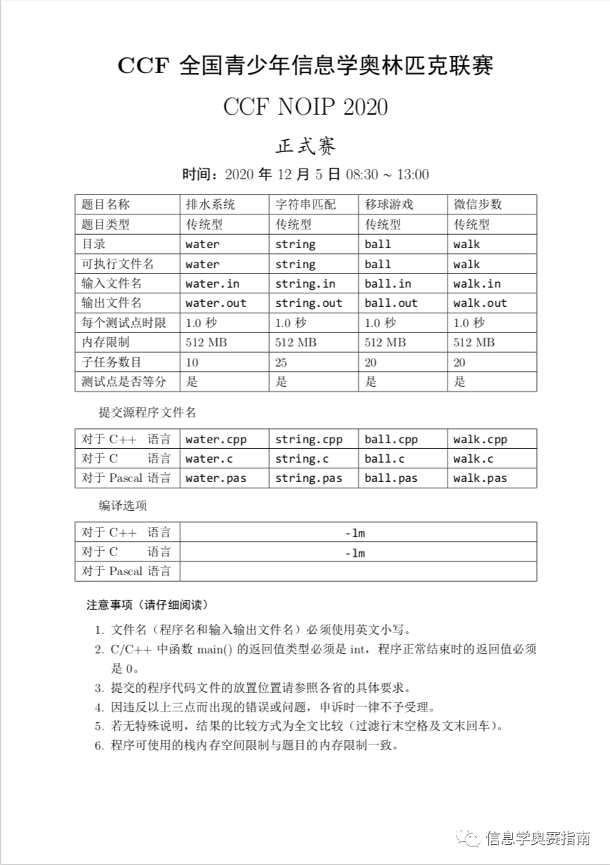

**NOIP 2020 试题**

